***Arab American University***

***Faculty of Engineering and Information Technology***

***Computer Systems Engineering***

**SENIOR PROJECT (II)**

*Engineering Faculty Compass*

*February 2024*

|  |  |
| --- | --- |
|  |  |
|  |  |

|  |
| --- |
| Supervised by: *Dr. Mahmoud Obaid,* |

|  |
| --- |
| **Computer Systems Engineering Dept.**  **Submitted in partial fulfillment of the requirements of B.Sc. Degree in Computer Systems Engineering**  *February 2024* |

**Students Statement**

We, the undersigned students, certify and confirm that the work submitted in this project report is entirely our own and has not been copied from any other source. Any material that has been used from other sources has been properly cited and acknowledged in the report.

We are fully aware that any copying or improper citation of references/sources used in this report will be considered plagiarism, which is a clear violation of the Code of Ethics of the Arab American University.

|  |  |
| --- | --- |
| Ayah Almoghayir (201911290) | Hala Nueirat (201911477) |
| Ruba Hardan (201912420) |
|  |

**Supervisor Certification**

This to certify that the work presented in this senior year project manuscript was carried out under my supervision, which is entitled:

“**Engineering Faculty Compass**”

|  |  |
| --- | --- |
| *Ayah Almoghayir (201911290)* | *Hala Nueirat (201911477)* |
| *Ruba Hardan (201912450)* |  |

I hereby that the aforementioned students have successfully finished their senior year project and by submitting this report they have fulfilled in partial the requirements of B.Sc. Degree in Engineering.

I also, hereby that I have **read, reviewed and corrected the technical content** of this report and I believe that it is adequate in scope, quality and content and it is in alignment with the ABET requirements and the department guidelines.

*Dr. Mahmoud Obaid,*

**ACKNOWLEDGMENT**

Let us first give thanks to God for all of His benefits, both now and in the future. Glory to God, who blessed us with the ability to realize the concept we presented in our first senior project through persistent effort and hard work in our second senior project.

We also want to sincerely thank Dr. Mahmoud Obaid, our wonderful supervisor, who helped us with the first and second senior projects and oversaw all of our suggestions and actions. We are grateful to our families, who have always been there for us and who will always pray for us. They were and will always be our first and last line of support.

Finally, we would like to thank Dr. Sami Awad for his helpful feedback and suggestions regarding our first senior project. And the doctors who supported us during our stay and imparted invaluable knowledge to help us get to where we are now. As well as our friends, who have been there for us from the beginning of this university, supporting us and sharing every moment with us.

**ABSTRACT**

The globe is seeing rapid technological advancements as well as the creation of cutting-edge tools and methods that simplify our lives, such as Augmented Reality (AR), technology. Every part of our life is being impacted by AR, and the world is moving toward it. Because navigating across huge, complex buildings like Engineering Faculty can be challenging and new students can be confused as to whether what is in the hall is a lecture for them or not. We have developed the Engineering Faculty Compass application by using Unity platform, this app uses AR to help new students find lecture halls by scanning the Quick Response (QR) code on the floor where the target hall is located, then selecting the desired hall from appeared halls list and following the line renderer that will appear until they reach the hall, in order to draw a shorter path from the QR code position to the desired hall, we used A* Algorithm to calculate the shortest path by divide each floor plan to grid and determine nodes inside it then draw the final path between the nodes that have the lowest costs. To solve the second part of the problem we used Screen Cloud to display the lecture information on a smart screen hanging on the hall door, this information including the name, time, number of students, the teacher, and the next lecture. The playlist is changed regularly, as it varies depending on the lectures offered by the university.

**List of Contents**

**Content page**

LIST OF FIGURES iv

LIST OF TABLES vi

LIST OF SYMBOLS AND ABBREVIATIONS vii

CHAPTER 1: Introduction 1

1.1 Problem Statement and Purpose 3

1.2 Project and Design Objectives 5

1.3 Intended Outcomes and Deliverables 6

1.4 Summary of Report Structure 7

CHAPTER2: Background 8

2.1 Overview 8

2.2 Related Work 9

**2.2.1** **Unique Shopping Mall Wayfinding Solution for Ülemiste** 9

**2.2.2** **Exhibition Centre Wayfinding: Dhahran Expo:** 10

**2.2.3 Amusement Park Wayfinding: Global Village** 11

**2.2.4** **Campus Wayfinding: Tallinn University of Technology (TAlTech)** 12

**2.2.5 Genesis Virtual Guide Hyundai Motor America** 13

**2.2.6 AR AlpineGuide** 14

**2.2.7** **Engineering Faculty Compass** 15

**2.2.8** **Related Works Comparisons** 16

CHAPTER 3: Methods and Materials 17

3.1System Design and Components 17

**3.1.1** **System Overview** 17

**3.1.2** **Flowchart** 19

**3.1.3** **Algorithm** 20

**3.1.4** **User Interface Design** 24

3.2 Design Specifications, Standards and Constraints 27

**3.2.1 Hardware Components And Specification:** 27

**3.2.2** **Software Specification** 30

**3.2.3** **System Requirements** 34

3.2.3.1 **Functional Requirements** 34

**3.2.4** **Packages and Plugins** 39

**3.2.5** **Cloud Screen Implementation** 39

3.3Design Alternatives 40

**3.3.1** **Bluetooth-Based Beacons** 40

**3.3.2** **Xibo Signage** 41

3.4 System Analysis and Optimization 42

**3.4.1** **Use Case Diagram** 42

**3.4.2** **Use Case Description** 43

**3.4.3** **Sequence diagram** 44

**3.4.4** **Activity diagram** 45

3.5 Simulation and/or Experimental Test 47

**3.5.1 Welcome Screen** 47

**3.5.2 Scan QR Code Screen** 48

**3.5.3 Ground Floor Halls Menu Screen** 48

**3.5.4 EIT001 hall path** 49

**3.5.5 First Floor Halls Menu Screen** 49

**3.5.6 EIT101 hall path** 50

**3.5.7 Second Floor Halls Menu Screen** 50

**3.5.8 EIT201 hall path** 51

CHAPTER 4: Results and Discussions 52

4.1 Results 52

**Engineering Faculty Compass Logo** 52

**Welcome Screen** 53

**Scan QR Code Screen** 54

**Halls Menu Screen** 55

**Tracking Screen** 56

**Screen Interfaces** 57

4.2 Discussions 59

**4.2.1 Discussion about Unity:** 59

**4.2.2 Discussion about Screen Cloud** 59

CHAPTER 5: Project Management 60

5.1 Tasks, Schedule and Milestones 60

5.2 Resources and Cost Management 61

5.3 Lessons Learned 61

CHAPTER 6: Impact Of The Engineering Solution 62

6.1 Economical, Societal and Global 62

**6.1.1** **Economical Impact:** 62

**6.1.2** **Societal Impact:** 62

6.2 Environmental and Ethical 63

**6.2.1 Environmental effects:** 63

6.3 Other Issues 63

CHAPTER 7: Conclusions and Recommendations 64

7.1Summary of Achievements of the Project Objectives 64

7.2 New Skills and Experiences Learnt 64

7.3Recommendations for Future Work 64

**7.3.1** **Recommendations** 64

**7.3.2** **Future Work** 65

References 66

APPENDICES 68

Appendix A: 68

Appendix B: 78

Appendix C: 78

**LIST OF FIGURES**

**Figure page**

Figure 1 Shopping Mall Wayfinder [2] 10

Figure 2 Dhahran Expo [2] 11

Figure 3 Global Village Wayfinding [2] 12

Figure 4 Genesis Virtual Guide [3] 14

Figure 5 AR AlpineGuide [4] 15

Figure 6 System Description 18

Figure 7 Engineering Faculty Compass Flowchart 20

Figure 8 A* Algorithm Flowchart 23

Figure 9 Welcome Screen 24

Figure 10 Scan QR Code 25

Figure 11 List of hall numbers screen 25

*Figure 12 Tracking screen* 26

Figure 13 Smart Screen [5] 27

Figure 14 Mobiles [6] 28

Figure 15 Unity Icon [7] 31

Figure 16 QR Code Generator [8] 32

Figure 17 C# Language [9] 33

Figure 18 Visual Studio [10] 33

Figure 19 Cloud Screen Application [11] 34

Figure 20 Bluetooth-Based Beacons [12] 40

Figure 21 Xibo Signage [13] 41

Figure 22 Engineering Faculty Compass Use Case Diagram 42

Figure 23 Sequence Diagram 45

Figure 24 Activity Diagram 46

Figure 25 Welcome Screen 47

Figure 26 Scan QR Code Screen 48

Figure 27 Ground Floor Halls Menu Screen 48

Figure 28 EIT001 hall path 49

Figure 29 First Floor Halls Menu Screen 49

Figure 30 EIT101 hall path 50

Figure 31 Second Floor Halls Menu Screen 50

Figure 32 EIT201 hall path 51

Figure 33 Application Logo 52

Figure 34 Welcome Screen 53

Figure 35 Scan QR Code Screen 54

Figure 36 Halls Menu Screen 55

Figure 37 Tracking Screen 56

Figure 38 Hall Information screen1 57

Figure 39 Hall Information Screen2 58

Figure 40 Hall Information Screen3 58

Figure 41 Hall Information Screen4 58

Figure 42 Gant Chart 60

**LIST OF TABLES**

**Table page**

Table 1 Shopping Mall Wayfinder VS Engineering Faculty Compass 9

Table 2 Dhahran Expo VS Engineering Faculty Compass 11

Table 3 Global Village Wayfinding VS Engineering Faculty Compass 12

Table 4 Campus Wayfinding VS Engineering Faculty Compass 13

Table 5 Genesis Virtual Guide VS Engineering Faculty Compass 13

Table 6 AR AlpineGuide VS Engineering Faculty Compass 14

Table 7 RELATED WORKS COMPARISIONS 16

Table 8 Stimulus/Response Sequence Enter To The Application. 35

Table 9 Stimulus/Response Sequence QR Code Scanning 35

Table 10 Stimulus/Response Sequence View a List of Hall Numbers. 36

Table 11 Use Case Open Application. 43

Table 12 Use Case Scan QR Code. 43

Table 13 Use Case Select The Hall. 43

Table 14 Use Case Follow Path. 44

Table 15 Sample Table To Fill In Total Cost Of Senior Project Items. 61

**LIST OF SYMBOLS AND ABBREVIATIONS**

This is where you should put all the symbols used and abbreviations **(must be sorted)**. It is stored in a table format same as the table of contents. Use inserts a row to add more entries…. etc.

|  |  |
| --- | --- |
| **LIST OF SYMBOLS** | |
| **$** | American dollar |
| **0** | Degree |
| **C#** | See sharp |
| **LIST OF ABBREVIATIONS** | |
| **ABET** | Accreditation Board for Engineering and Technology |
| **AR** | Augmented Reality |
| **VR** | Virtual Reality |
| **QR** | Quick Response |
| **IOS** | iPhone Operating System |
| **URL** | Uniform Resource Locator |
| **GPS** | Global Positioning System |
| **POI** | Points Of Interest |
| **IT** | Information Technology |
| **App** | Application |
| **3D** | Three Dimensional |
| **UML** | Unified Modeling Language |
| **AAUP** | Arab American University |
| **PC** | Personal Computer |
| **EIT** | Engineering and Information Technology |
| **APK** | Android Application Package |
| **API** | Application Programmable Interface |
| **UI** | User Interface |
| **GB** | Gigabyte |
| **MB** | Megabyte |

**CHAPTER 1: Introduction**

Finding the halls, they wish to visit can be difficult for visitors and new students at the Engineering Faculty. A further confusion among new students is whether this lecture hall hosts their lecture or one for a different subject. We have developed Engineering Faculty Compass application that uses AR technology to help students reach their halls by selecting the name of the hall in order to address these issues. We employed screens to show crucial information about the hall so that students could be sure they were in the lecture meant for them.

The reason we called the app "Engineering Faculty Compass" is that it acts as a compass, pointing users in the direction of the Qibla for prayer, while ours points the user in the right direction to the desired hall at Engineering Faculty.

As the advancement in technology, location-based services are commonly used. Navigation system help users find destination easily especially in the unfamiliar area. Indoor navigation is the process locating oneself and traveling inside building, while outdoor navigation is used outside building. We developed AR indoor navigation application help users find desired destination easily in Engineering Faculty.

Since Global Positioning System (GPS) signal is too weak inside building, is more appropriate for outside navigation. Another solution of indoor navigation using beacons but it requires routine maintenance such as changing the batteries. As a result, we are developing smartphone application that give path to desired destination by scanning QR code. In this project we used QR code as trigger due to its ability to store a lot of data in a little space, simple to use and inexpensive.

A VR technology called Virtual Reality (VR) allows users to have visual experiences through the use of pictures and videos. Creating a Three-Dimensional (3D) environment simulation that the user can fully interact with through the use of VR glasses and wireless controls is the primary objective of this technology. Put differently, VR technology generates an entirely new world that the user can engage with and fully submerge himself in, just like he was physically present in it.

With the use of a variety of virtual details, including sound, video, and images, AR technology improves both the physical world and its live view. This technology's main goal is to augment real reality with virtual components. AR, to put it simply, is a technology that attempts to merge the virtual world that contemporary devices create with the real world we live in. Having defined both technologies, we can conclude that AR aims to bring the virtual into the real world, whereas VR seeks to completely replace the real world with a virtual environment in which one can interact and immerse oneself.

AR and VR are two different technologies. AR refers to the technology that add digital elements to the real world by opening the camera so that it appears in the real word. It uses less hardware and less isolating than VR. VR it is completely fictional that replace real environment with virtual environment and require headset device.

In 2019, there were approximately **0.44 billion** active AR user devices. By 2021, this number had almost doubled to **0.81 billion**. As of 2023, there are **1.4 billion** AR user devices in active use. And this indicate the important of AR will be increase more and more in future [1].

## **1.1 Problem Statement and Purpose**

For students, faculty, and visitors, navigating sizable university campus like the Faculty of Engineering—can be a challenge. Buildings' intricate floor plans, number of floors, and number of hallways frequently cause confusion and waste time when attempting to locate specific areas. Traditional maps and signage aren't always enough, especially for visitors or people who don't know much about a university campus. Frustration, delays, and decreased productivity follow from this.

The purpose of this application is to utilize AR technology to simplify and enhance navigation within the Faculty of Engineering. By providing users with an intuitive interface and visual guidance, the application aims to help users easily find their desired halls on different floors.

The user experience will be further enhanced by installing smart display screens in front of each hall, which will offer comprehensive information about the hall's primary function. This application aims to address the following goal by utilizing AR and smart displays.

1. Making navigation easier: The app provides users with a quick, easy and efficient way to navigate the Faculty of Engineering. Users can scan the QR code that exist on the target floor and then choose the desired hall from the list that will appear, and the application will then design a unique route to get them there quickly and efficiently.

2. Enhanced user Interaction: The application uses AR technology to give users a more interesting experience. Navigation is made more intuitive and interactive with the use of visual icons and overlay virtual paths that are visible through the camera.

3. Increased Productivity: The app will help users increase their productivity by decreasing the amount of time they need to spend looking for a particular location. Users can locate their destinations quickly and easily, reducing interruptions and maximizing their time for activities.

4. Providing information: The information hub will be the intelligent display screens positioned in front of each hall. They enable users to communicate and spread awareness within the Faculty of Engineering by giving them access to precise information and hall details.

In summary, the purpose of this application is to use AR and QR code to make it easier for users to navigate the Faculty of Engineering. By addressing the difficulties that come with locating specific locations on a large, complex campus, the app hopes to increase user productivity and engagement and obtain detailed information about the desired hall through the screen hanging on its door.

## **1.2 Project and Design Objectives**

Project and design objectives that achieved in the second senior project.

1. Make navigating the Faculty of Engineering simple and effective using AR.

2. Designing the application scalable, enabling expansion and integration with new features or technologies in the future as needed.

3. Designing an app compatible with Android mobile devices in Application Programmable Package (APK) format.

4. Integrate AR overlays seamlessly with the device's camera to deliver precise visual icons.

## **1.3 Intended Outcomes and Deliverables**

**Intended Outcomes:**

1. Enhance communication and awareness: Through the display screens, users can learn specifics about the hall.

**Deliverables:**

1. Engineering Faculty Compass App: AR app suitable for Android mobile devices. The application has a simple user interface, the ability to scan QR, the ability to identify the hall, AR overlays for navigation, and the ability to create routes.

2. The project included display screen that provide the user with all the information they require about the hall. For the user, this information will be priceless.

3. Engineering Faculty Compass Document Report.

## **1.4 Summary of Report Structure**

Our report is divided into several chapters, and each chapter performs a particular duty within the overall structure of the document. In the first chapter the problem that our project aims to solve, the motivation behind it, its goals and design, as well as its anticipated outcomes and accomplishments. The context of the project is described in the second chapter, which has been split into two sections: an overview and a discussion of Systems like us. This section contains information on all comparable job systems that we found while compiling the report. The third chapter will cover system design and its elements, design requirements, algorithm, implementation, packages and plugins, criteria, limitations, design alternatives, system analysis and optimization, simulation, and/or pilot testing. The results of our senior project will be included in the fourth chapter, with a discussion of them. The steps we took to manage our project including use the Gant Chart, assign tasks to group members, identify the resources we needed, and estimate their costs are detailed in the fifth chapter. The sixth chapter will discuss how our project has affected different fields, including the economy, society, and the environment. In the seventh chapter, we will discuss the objectives we met for the project, new skills and experiences we earned, and finally, we will offer some guidelines and recommendations for projects that will be similar to ours in the future.

**CHAPTER2: Background**

## **2.1 Overview**

The application aims to bring about a qualitative shift in mobility within the Faculty of Engineering. Through AR, visual cues and paths that the application provides to the user, it provides a smooth and efficient way to navigate through floors and halls. Once the user opens the application, an interface will appear to him through which he can go to the camera to scan the QR. Through the QR code assigned to each hall, a dropdown menu will open that includes the names of the halls for each floor. Once a hall is selected, the application creates a path for that hall customized as requested by the user and overlays it with AR using the mobile device's camera. The user's mobile phone camera shows the live routes until he reaches his destination. When he arrives at his destination, he will find a display screen that provides him with information about the hall he wants.

## **2.2 Related Work**

### **2.2.1** **Unique Shopping Mall Wayfinding Solution for Ülemiste**

In Tallinn, Estonia, there is a sizable shopping complex with 220 stores as well as scores of eateries and cafes. Additionally, it is close to the main bus station and the Tallinn Airport. It is extremely crowded because it connects tram, bus, and train routes. A dual approach to kiosks has been implemented along with a mobile application to make this center accessible to all. Kiosks have been placed throughout the center so that they include a layout of the center so that people can see the layout of the floors and other information. We can search for particular stores so that the visitor's location is determined through the I Beacons. In addition to application's ability to operate in the three languages of Estonian, Russian, and English [2].

Table 1 Shopping Mall Wayfinder VS Engineering Faculty Compass

|  |  |
| --- | --- |
| **Shopping Mall Wayfinder** | **Engineering Faculty Compass** |
| For very large building. | For small building. |
| Using mobile application and kiosk. | Using mobile application and screen. |
| Operating in three languages. | Operating in one language (English). |
| For finding stores. | For finding halls. |
| Using by all people who visited the center. | Using by all people who visited the faculty. |

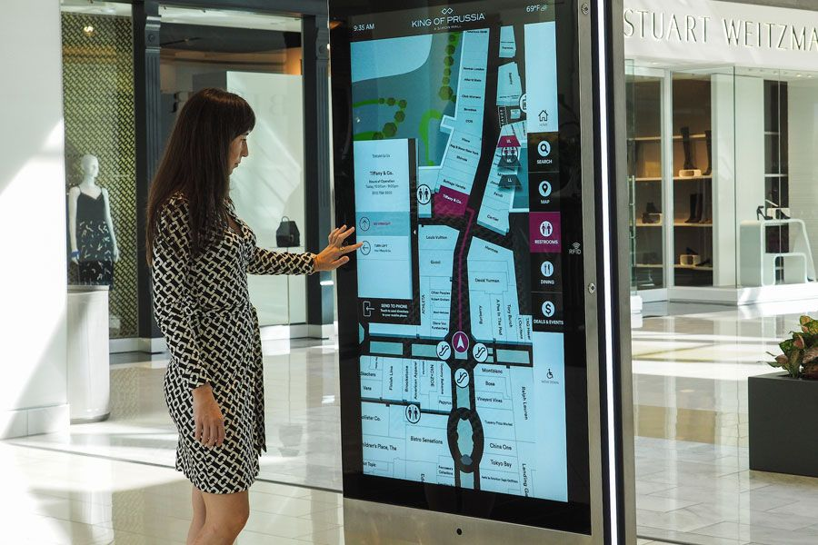

Figure 1 Shopping Mall Wayfinder [2]

### **2.2.2** **Exhibition Centre Wayfinding: Dhahran Expo:**

Dhahran Expo put the kiosk idea into practice by building a 3D model of the site, complete with exposition halls, seminar rooms, an outdoor display area, a business center, a media center, a mosque, and parking spaces. The kiosk allows participants to look up certain booths or activities and get driving instructions to their desired location. Shortcut buttons were made for sites that were regularly used, such the mosque and restrooms, to streamline the process. The kiosk also gives users the option to see the distance and anticipated travel time to their destination. You can print coupons, interactive notifications, ads, and accreditation cards to personalize the wayfinding and kiosk use in the exposition center. Utilizing usage information, organizers can make the required changes for.

For large venues such as Dhahran Expo, another effective solution is to use our mobile app, which provides indoor navigation. Since kiosks may not be for everyone in a crowded space, the flexibility and accessibility of the mobile app makes it a great alternative. It can be downloaded and used by anyone, anywhere, anytime, providing up-to-date information on upcoming events, schedule changes, weather forecasts, and public transportation. Another option is to integrate the route find feature into the venue’s existing website, allowing visitors to pre-plan their movements by providing a 3D model of the venue [2] .

Table 2 Dhahran Expo VS Engineering Faculty Compass

|  |  |
| --- | --- |
| **Dhahran Expo** | **Engineering Faculty Compass** |
| Using mobile application and kiosk | Using mobile application and screen. |
| See the distance and time of arrival | see track. |
| Print cards to facilitate the search | Track the track via the app. |
| GIS integration with the application. | Integration of the track with the application. |
| Using by all people who visited the center. | Using by all people who visited the faculty. |

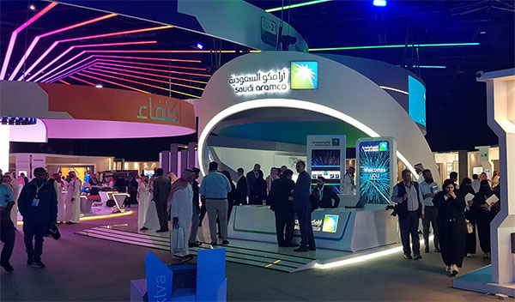

Figure 2 Dhahran Expo [2]

### **2.2.3 Amusement Park Wayfinding: Global Village**

The WhatsApp app already includes 3D wayfinding, so users won’t need to download anything else. To start the chatbot, the visitor sends any number, and then enters the location he wants to go to. A URL with a two-dimensional map of the way to the desired location is sent by the chatbot. GPS is used to pinpoint the device’s location because the Global Village is an outside location. The visitor views details about the place he wants to visit [2].

Table 3 Global Village Wayfinding VS Engineering Faculty Compass

|  |  |
| --- | --- |
| **Global Village Wayfinding** | **Engineering Faculty Compass** |
| Using WhatsApp application. | Using mobile application and screen. |
| Enter the desired location. | Enter hall number. |
| For large area (1600000sqm). | For small area (3 floors). |
| Using GPS. | Using QR code. |
| Using by all people who visited Global Village. | Using by all people who visited the faculty. |

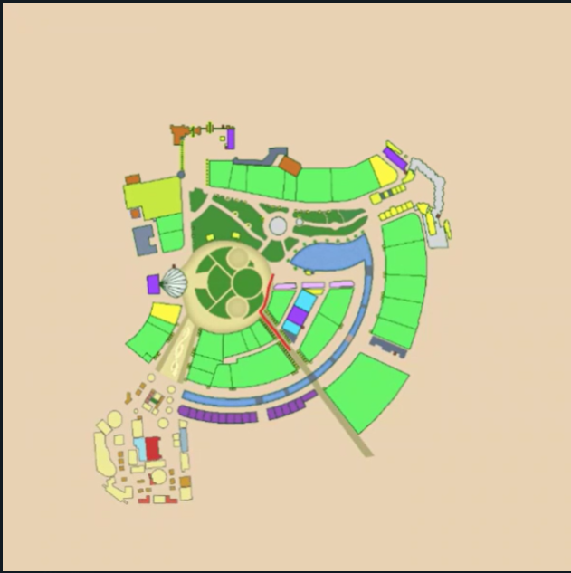

Figure 3 Global Village Wayfinding [2]

### **2.2.4** **Campus Wayfinding: Tallinn University of Technology (TAlTech)**

A 3D wayfinder has been used by a top university for engineering and technology education as a map of the campus. The building directory spans more than 133,000 square meters and has more than a thousand rooms.

A kiosk with an online map was built, and a 3D model of the campus was created. The solution lists all lecture halls, offices, dining rooms and services. Mobile applications are another option, as practically everyone always carries one with them. Mobile device indoor positioning is accomplished using low energy Bluetooth beacons. These beacons establish the user’s location by triangulation, and the software creates a visually appealing route to the targeted location [2].

Table 4 Campus Wayfinding VS Engineering Faculty Compass

|  |  |
| --- | --- |
| **Campus Wayfinding** | **Engineering Faculty Compass** |
| Using mobile application and kiosk. | Using mobile application and screen. |
| For very large building (133000sqm). | For small building. |
| Using by students, staff and visitors in TalTech university. | Using by all people who visited the faculty. |

### **2.2.5 Genesis Virtual Guide Hyundai Motor America**

It is an application that can be downloaded on smart devices and is available on App Store. It makes use of AR to precisely identify automobile components and their functions using the camera and sensors. It also aids drivers in diagnosing and resolving straightforward issues, saving time and effort by utilizing and allowing them to see all of its details in a three-dimensional image [3].

Table 5 Genesis Virtual Guide VS Engineering Faculty Compass

|  |  |
| --- | --- |
| **Genesis Virtual Guide** | **Engineering Faculty Compass** |
| Using mobile application only. | Using mobile application and screen. |
| For Hyundai Cars. | For small building (Engineering Faculty). |
| Using by drivers and employees in the company. | Using by all people who visited the faculty. |
| Available only in App Store (ios operating system). | Available in Google Play (Android Operating system). |
| You need opening the camera to see the information about any part. | You need only entering the number of hall to find the place of it. |
| This system uses cameras and sensors. | Our system use cameras. |

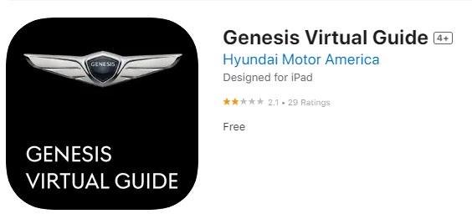

Figure 4 Genesis Virtual Guide [3]

### **2.2.6 AR AlpineGuide**

This application uses AR, and when the camera is pointed towards a mountain peak, the name of the peak, its height, and its distance are displayed. If the device is tilted, three-dimensional coordinates and a gyroscope are also displayed [4].

Table 6 AR AlpineGuide VS Engineering Faculty Compass

|  |  |
| --- | --- |
| **AR AlpineGuide** | **Engineering Faculty Compass** |
| Using mobile application only. | Using mobile application and screen. |
| To know the height of the mountain peaks, their names, and the distance from them. | To identify the locations of halls at faculty of Engineering. |
| Using by anyone. | Using by all people who visited the faculty. |

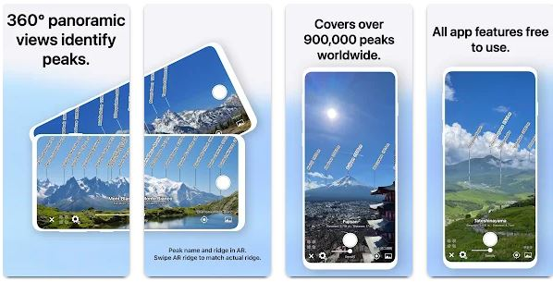

Figure 5 AR AlpineGuide [4]

### **2.2.7** **Engineering Faculty Compass**

An application was created to make it simpler for staff and students at the Arab American University (AAUP) to find the hall in the Faculty of Engineering. You can access the application. Students can select their halls and indicate whether or not they are aware of the halls' activity times using the application's 3D model of the faculty building created using AR. The application is distinctive. by showing the empty hall numbers and the user's route to the chosen hall in an easily accessible box on the program interface. Users can download the app on Android devices.

**2.2.8** **Related Works Comparisons**

Table 7 RELATED WORKS COMPARISIONS

|  |  |  |  |  |  |  |  |
| --- | --- | --- | --- | --- | --- | --- | --- |
| Project Name | Ülemiste Center | Dhahran Expo | Global Village | TALTECH | Genesis Virtual Guide | AR Alpine Guide | *Engineering Compass* |
| Large building | ✔ | ✔ | ✔ | ✔ | ✖ | ✖ | ✖ |
| Mobile  Application | ✔ | ✔ | ✔ | ✔ | ✔ | ✔ | ✔ |
| English  Language | ✔ | ✔ | ✔ | ✔ | ✔ | ✔ | ✔ |
| Place finding | ✔ | ✔ | ✔ | ✔ | ✖ | ✖ | ✔ |
| All people using | ✔ | ✔ | ✔ | ✔ | ✖ | ✔ | ✔ |
| Using track | ✔ | ✔ | ✔ | ✔ | ✖ | ✖ | ✔ |

# **CHAPTER 3: Methods and Materials**

We will discuss the basic requirements of our project, whether they pertain to software or hardware, as well as the main functions and features that must be applied to it, in this section. We will use a use case diagram, a sequence diagram, an activity diagram, a context diagram, a user interface, and the relationships between them to explain everything.

## **3.1System Design and Components**

It lists the necessary hardware and software as well as the primary tasks that our project will accomplish once it is put into use. It also lists non-functional requirements. And the implementation of our project.

### **3.1.1** **System Overview**

In our project we have five scenes, panorama scene, QR code scene, ground floor scene, first floor scene, and second floor scene. We downloaded AR Foundation framework to enable our application interact with real world. Because our application works on Android devices, we install AR Core tool from AR Foundation framework. In this project we used several inputs such as, AR camera, QR code, plans for each floor that we got them from university resources to build the 3D model for each floor independently, and 3D model of our Engineering Faculty. AR camera is device used to capture real-world environment and integrate virtual object onto it. It helps AR system understands physical objects like walls and surfaces. The AR camera helps in providing real time navigation guidance by analyzing the captured images. To determine start position we placed one QR code in each floor. Once the QR scanned the application display dropdown list of halls in the desired floor. We used three planes for each floor in Engineering Faculty to build 3D model for each of them. We build 3D model in unity using 3D cubes and we put all these cubes on wall layer to use them to show the path to the desired hall. We put cubes as a marker in each hall to use it as target position, once the user scanning the QR code and determine user position at this point, the application display a dropdown list of the halls, then the user select the target hall, the application takes the position of the cube in the selected hall, and then use A* pathfinding algorithm to calculate the shortest path between start and target position. To show the path we used line renderer component that draw a line from start position to the target position. After reach the desired hall, the screen displays information about this hall such as course name, lecturer name, the duration of the lecture, and the number of students in the lecture this information is coming from room manager and then put them manually in the two playlists the first one for Sunday, Tuesday and Thursday days and the other for Monday and Wednesday days.

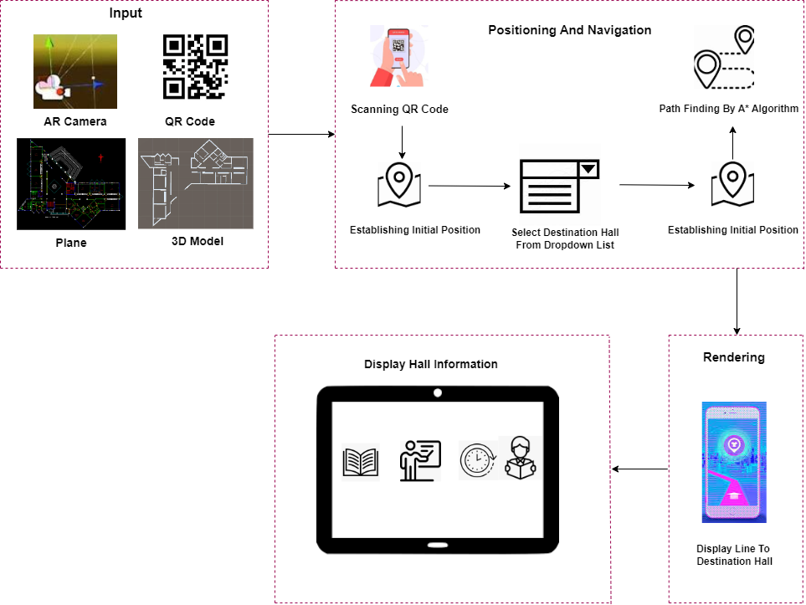

Figure 6 System Description

### **3.1.2** **Flowchart**

It includes a flowchart outlining how our application operates and a use case diagram with actors from basic.

Figure 7 shows a flow chart of the Engineering Faculty Compass. The user first goes to desired floor and logs into the application. The user scans the QR code in desired floor to access the required data. A two-dimensional bar code called a QR code can be printed as an image on each floor. QR code has many advantages over previous methods, including being much easier for the camera and user to read and lower maintenance costs. The AR app displays a list of navigation options (hall numbers) after scanning the QR code and successfully locating the user. The program displays a route to the chosen hall once selected.

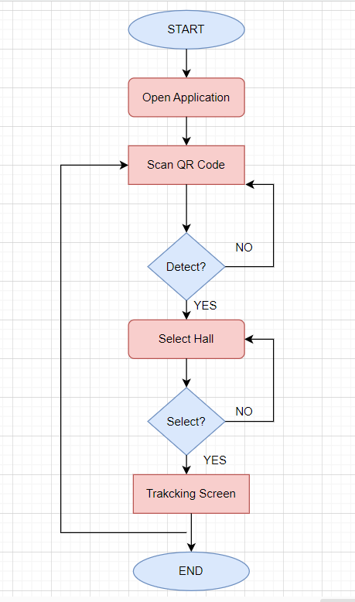

Figure 7 Engineering Faculty Compass Flowchart

### **3.1.3** **Algorithm**

In our application we used A* algorithm because it is one of the best technique used in path finding and graph traversals. Unlike other traversal strategies, A* search algorithms have brains. Given that it is a sophisticated technique with the capacity to make defensible judgments throughout searches, much like the brain. This indicates that, in contrast to other technologies, it is genuinely an intelligent algorithm. This algorithm is widely used in web-based games and maps to quickly determine the shortest path.

**A* Algorithm usage in Engineering Faculty Compass App:**

This algorithm was applied on each floor independently to determine the distance between the destination hall and the starting point where the QR Code exist. We used a grid-based system. This grid consists of a collection of cells, and each cell is a node. Each node has divided coordinates entry in the x, y, and z (global location) axes and Grid coordinates (iGridX, iGridY, iGridZ). Nodes come in two varieties: those that permit passage through and wall that act as obstacle to. Every node must have three parameters: G cost, H cost, and F cost. G cost is the actual cost of movement from the start node to the current considered node. So the G cost of the starting node is 0. This cost increases as we get closer to the goal (the end node). H cost is the estimated cost or heuristic cost from the current considered node to the end node without considering any obstacles. The H cost of the end node is 0. As we approach the end node, the heuristic cost decreases. We used the Manhattan distance to calculate the H cost between two nodes based on the x and y coordinates of each node. The Manhattan distance is the sum of the absolute differences in the x and y coordinates between two nodes. F cost is the sum of G cost and H cost.

$$Manhatten Distance=$$

$\left|Node1 Grid.x-Node2 Grid.x\right|+\left|Node1 Grid.y-Node2 Grid.y\right|$---------- Eq 1

$F_{cost}$ = $G_{cost}$ + $H_{cost}$-------- Eq 2

In order to make the algorithm work, we need two lists of nodes. The first is the open list, which contains all nodes to be evaluated and can be considered as path points. The second is the closed list, which contains nodes that have already been visited and evaluated.

This figure shows how the A* algorithm works. The algorithm initializes by adding the start node to the open list, then iterates until either the target node is discovered or the open list is empty. Within each iteration, it selects the node with the lowest F cost from the open list. This selected node is removed from the open list and added to a closed list. If the chosen node is the target, the algorithm terminates. Otherwise, for each neighboring node, check if it's a wall or on the closed list. If not, it calculates a new G cost, updates parameters if necessary, and adds the neighbor to the open list if it is not already present.

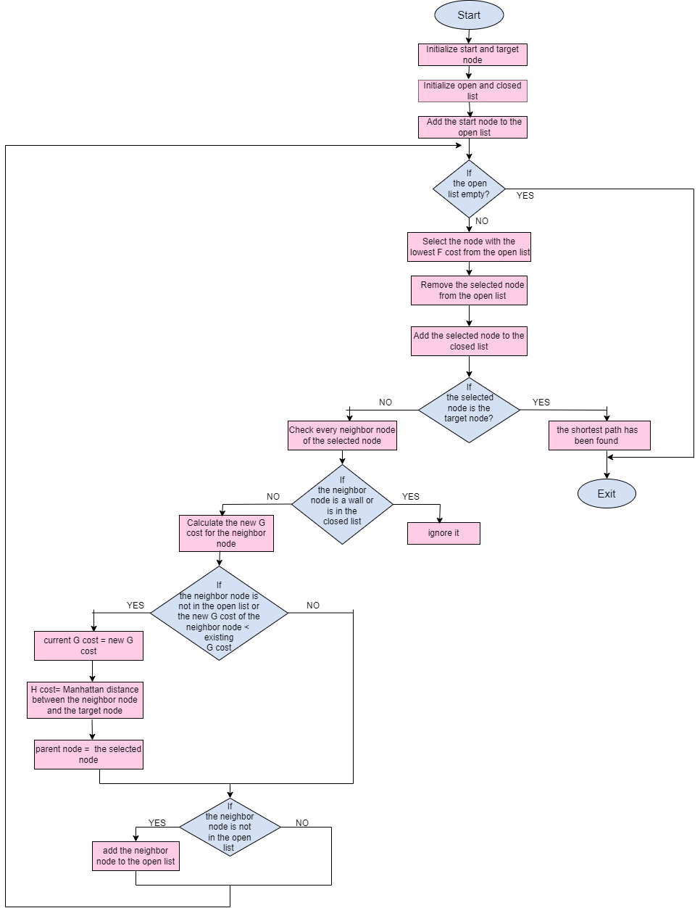

Figure 8 A* Algorithm Flowchart

Then line renderer component starts drawing a path along the shortest path found by the A* algorithm after figuring out the grid of nodes that connects the starting point to the target node [15].

### **3.1.4** **User Interface Design**

It includes the main interfaces that will be displayed in order from the time you enter the application until you get to the required hall.

#### 3.1.4.1 Welcome Screen

The Figure 9 welcome screen for the users when they login.

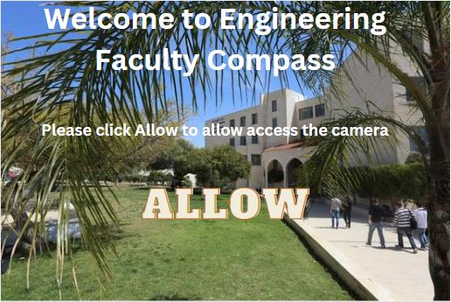

Figure 9 Welcome Screen

#### 3.1.4.2 Scanning QR screen

The Figure 10 scan QR code for the users to display the hall numbers.



Figure 10 Scan QR Code

#### 3.1.4.3 List of hall numbers screen.

The Figure 11 list of halls numbers screen after scanning the QR.

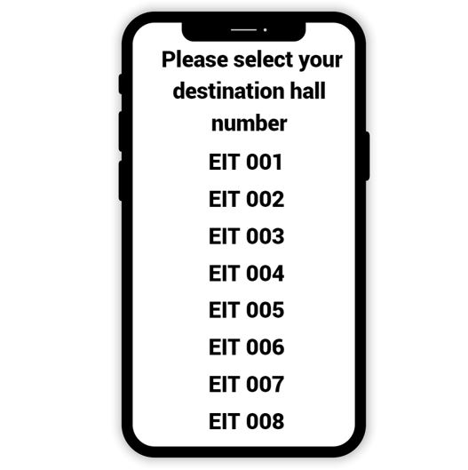

Figure 11 List of hall numbers screen

#### 3.1.4.4 Tracking screen

The Figure 12 screen tracking down to selected hall while the camera is opened.

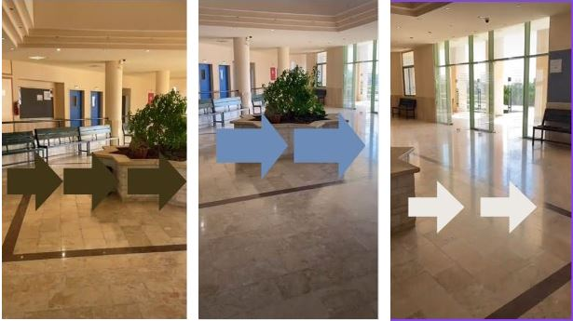*Figure 12 Tracking screen*

## **3.2** **Design Specifications, Standards and Constraints**

### **3.2.1 Hardware Components And Specification:**

In this section, we will show how the major hardware component of our project works, explain why we chose them.

#### 3.2.1.1 Smart Screen

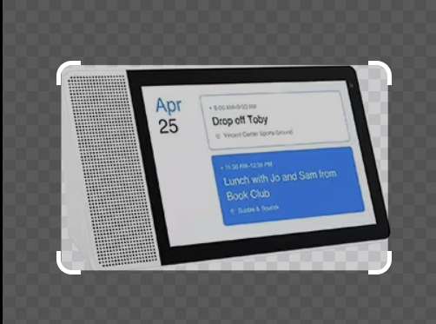

Figure 13 Smart Screen [5]

**Description:**

A display screen is referred to as a smart screen. The capabilities and functionalities of a smart screen typically go beyond those of a conventional screen. To improve its functionality and communicate with the user, it has features and technology.

Several of our system's smart screen features include:

1. High resolution: The smart screen needs to be able to display information precisely and clearly to make it easier to read.

2. Information Integration: The information must fit in with the room in which it is exhibited and be consistent with it.

3. Control: It can be controlled by experts in terms of the information's presentation or content.

#### 3.2.1.2 Mobile

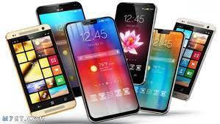

Figure 14 Mobiles [6]

**Description:**

The following characteristics and skills are commonly present on a mobile device that may interact with an AR application:

1. Display: Gadget has to feature a high-quality screen with accurate color and resolution. By doing this, it is made sure that the AR content overlays the real-world view smoothly and attractively.
2. Computing Power: To execute QR detection, tracking, and display, AR apps frequently need a lot of computing power. To effectively manage these computational duties, the gadget needs a strong CPU.
3. Camera: A back camera on the mobile device must have sufficient resolution and quality. The camera is necessary to capture the QR code and adhere to the standard visual indications.
4. Connectivity: In order to read and reply to a QR code, mobile devices must have a high-speed internet connection.

#### 3.2.1.3 Personal Computer (PC)

**Description:**

The minimum specification of a PC for unity development:

1. Processor (CPU): Intel Core i5 or AMD Ryzen 5.
2. RAM:8 GB.
3. Storage: 256 GB HDD.
4. Operating System: Unity is compatible with Windows and macOS.
5. Input Devices: mouse for navigating Unity's interface, keyboard for coding and general input.
6. Display: a monitor with at least 1920x1080 resolution.

### **3.2.2** **Software Specification**

#### 3.2.2.1 Unity platform

It's one of the most widely used game engines and it holds great potential for AR applications. Unity can help create 3D models of indoor spaces and integrate them into an AR experience on mobile devices. This software enables developers to build an intuitive, user-friendly interface for navigating large buildings. It also helps users identify locations within a building using visual markers.

There are a several reasons why we choose the unity platform:

* 1. AR Foundation Framework

AR Foundation enabling the application to understand and interact with real-world surfaces.

* 1. Large Developer Community

Unity has a large and active community of developers, providing a wealth of resources, tutorials, and shared knowledge.

* 1. Asset Store

Unity has pre-built assets such as 3D models, AR frameworks, and other tools. It saves the development time and efforts, also it easy integrates them into projects.

* 1. Ease of Use

Unity is known for its user friendly interfaces and ease of use, making it accessible for both experienced developer and those new to AR development. The visual editor enables the developers design AR experience without extensive coding.

* 1. 3D Rendering and Graphics Capabilities

Unity enable developers to create immersive AR environments and realistic visualizations in indoor navigation projects.

* 1. Real-Time Development and Testing

Unity enable developers to see immediate changes in the editor, facilitating an iterative development process. This is valuable for refining user interfaces in an AR context.



Figure 15 Unity Icon [7]

#### 3.2.2.2 QR code generator

AR navigation projects use QR generator software to create QR codes with unique information about a specific location, which can be scanned using a smartphone or tablet camera to access content like direction. QR generator software provides a new and innovative way to navigate through complex environments, while also providing an easy way to customize the content for each code. Additionally, QR generator software ensures the smooth operation and accuracy of AR navigation projects, improving their functionality and effectiveness.

Here's how to generate QR code:

1. Install the ZXing Unity library. This module makes it possible to generate QR codes in Unity projects [15].
2. We Added the ZXing library to your Unity project by importing it. To use the ZXing package's capabilities, import it into your Unity project at this step.
3. We wrote a script to manage the creation of QR codes. One way to do this is by writing a new script in Unity that will generate the QR code.
4. We used the data required to be encoded into the QR code, then generate the bitmap of the QR code by writing the information (the names of floors) that we want to save it in QR code then generate QR code in QR code generator website [8].
5. We take a new Texture2D object and add the bitmap of the QR code to it.
6. In our Unity scene, we applied the created QR code texture to a material or user interface element. This stage entails giving a material or QR code texture.



Figure 16 QR Code Generator [8]

#### 3.2.2.3 C# language

For creating AR indoor navigation applications, Unity's C# language is a critical component. Its strong feature set enables developers to make interactive and captivating applications. Designers can quickly use Unity's extensive toolbox of APIs and libraries using C# programming to create unique solutions for challenging problems that arise during the creation of indoor navigation. The C# programming language aids in code quality optimization, app performance enhancement, and user experience improvement for simulation games.



Figure 17 C# Language [9]

#### 3.2.2.4 Visual Studio

Visual Studio serves as an integrated development environment (IDE) for scripting and programming in Unity projects. When working with Unity, Visual Studio is often used for writing, editing, debugging, and managing C# scripts, which are commonly used in Unity application development [10].



Figure 18 Visual Studio [10]

#### 3.2.2.5 Screen Cloud

By connecting to the screen cloud player application, the screen cloud application seeks to enhance the digital display of screens utilized in public areas by enabling users to customize interfaces, schedule them, and set the duration of display to their preferences. Every screen gets a unique icon when you download the screen cloud player application. He can use it to project the presentation onto the screen, and by establishing a connection with the cloud, the material is automatically updated, simplifying the process of updating and changing it. [11]



Figure 19 Cloud Screen Application [11]

### **3.2.3** **System Requirements**

### 3.2.3.1 **Functional Requirements**

When developing software, functional requirements determine what the system must accomplish or what tasks it must perform to meet the needs of users or stakeholders. These specifications specify the exact features and behaviors that the software must have in order to service its intended function.

Functional requirements determine the inputs and processing that the program must perform as well as the outputs that must be generated as a result. Functional needs include:

**3.2.3.1.1** **Users must be able to enter to the application**

* By clicking on the application.

Stimulus/Response Sequence:

Table 8 Stimulus/Response Sequence Enter To The Application.

|  |  |
| --- | --- |
| Stimulus: | Click on the application. |
| Response: | Welcome screen displayed. |

##### **3.2.3.1.2** **QR Code Scanning**

* Enable users to scan QR codes placed throughout the Faculty of Engineering.
* support for QR code scanning with the camera on the device.

Stimulus/Response Sequence:

Table 9 Stimulus/Response Sequence QR Code Scanning

|  |  |
| --- | --- |
| Stimulus: | Scan the QR code. |
| Response: | List of hall numbers displayed. |

##### **3.2.3.1.3** **View a list of hall numbers.**

Stimulus/Response Sequence:

Table 10 Stimulus/Response Sequence View a List of Hall Numbers.

|  |  |
| --- | --- |
| Stimulus: | List of hall numbers displayed. |
| Response: | Select hall from the list that you want to go to it. |

#### *3.2.3.1*.4 Destination Hall

* Present destination with AR elements.

##### **3.2.3.1.4.1 Wayfinding And Points Of Interest (Poi):**

* Put QR codes in particular POIs or locations inside the faculty in each floor.

##### **3.2.3.1.4.2 SMART Screen:**

This interactive display serves as an information hub, offering valuable details about the hall, including the name of the current lecture, lecturer name, duration of the lecture, and the number of student in the lecture.

#### 3.2.3.2 Nonfunctional Requirements

The features or attributes that the software system must possess or display to satisfy the needs of its users or stakeholders are referred to as non-functional requirements in software development. These requirements—often referred to as "quality attributes" or "system qualities"—are concentrated on features of the software system that are not immediately connected to its functional capabilities.

Non-functional requirements could cover things like the system's usability, maintainability, reliability and performance among other things that affect the system's overall quality. Non-functional needs include:

##### **3.2.3.2.1 Product Requirements**

1. Response time:

The system must respond to user requests within a 30 sec.

2. Availability:

The system must be available for use all the time it needed.

3. Scalability:

We used A* algorithm method can have adapted to different floor plans and environments. It allows for the adjustment of parameters such as node size to make it scalable to various scenarios.

4. Usability:

Our system is simple to use because it has obvious icons for the user to click on to move to the next interface.

5. Accessibility:

Since registration is not necessary to use the system, it will be available to all students and visitors. Simply enter it to use it.

6. Integration

Our system will integrate QR code scanning with mobile applications, AR, and 3D models, as well as directions and information display.

##### **3.2.3.2.2 Organizational Requirements**

1.Environmental Requirement:

Our software is an application; it can be accessed from different devices with Android operating systems.

2.Operational Requirement:

Our application will be used by people who need to take refuge in the Faculty of Engineering to take them from their place to the place they need and it will also provide the users with all their needs.

### **Packages and Plugins**

1. AR Foundation:

AR Foundation is Unity's framework for creating AR experiences on iOS and Android devices, offering a common API for AR to work with different platforms, such as ARCore for Android. This framework supports marker-based tracking, which is essential for detecting QR codes in the indoor navigation system.

1. ZXing.Net:

ZXing.Net is a popular open source library for reading QR codes in Unity. It helps decode QR codes from camera frames, enabling the app to recognize QR code tags within an AR scene.

1. LeanTween:

LeanTween is an animation library for Unity.  It provides a simple API for creating tweens.  It's used to move an object along a specified path. We downloaded LeanTween from the Unity Asset Store.

### **Cloud Screen Implementation**

The first thing we did was make two playlists: one for the Sunday, Thursday, and Tuesday lectures, and another for the Monday and Wednesday lectures. Once the playlists are added to the channel, make sure to specify the dates and times for each playlist. After setting the channel on the screen, install Screen Cloud Player on the smart screen, get the code to enter on the Cloud Screen website, and connect the screen to Cloud Screen before adding anything more.

## **3.3Design Alternatives**

### **3.3.1** **Bluetooth-Based Beacons**

To locate the hallways, we first thought about using sensors, which are tiny devices that send signals to other nearby devices. In order for users' devices to pick up these signals and use them to determine their location, they are dispersed throughout the building. We will need a lot of sensors because the Faculty of Engineering has a lot of halls.

Accuracy, Low Energy Consumption, Compatibility, Ease of Deployment, and Offline Functionality are a few of the main advantages of Bluetooth based Beacons [9].

There are many beacons that are expensive and labor-intensive to program because the Faculty of Engineering has so many halls. We opted to use QR codes instead. A few of the main advantages of QR codes include their simplicity in implementation, cost effectiveness, versatility, user engagement, quickness and convenience, and scalability.

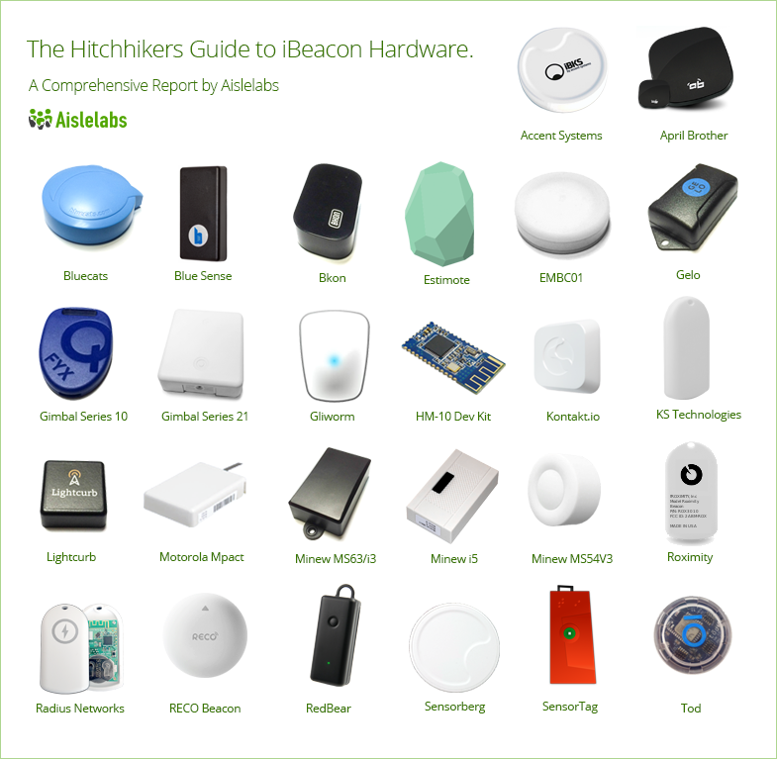

Figure 20 Bluetooth-Based Beacons [12]

### **3.3.2** **Xibo Signage**

When we started our first senior project, we suggested using the Xibo program to display information on the screen in attractive formats and in the order that the lectures would last. However, as time went on, we learned that the Xibo program was difficult to use, required programming languages to understand, and had an unclear user interface. Instead, we replaced it with the Cloud Screen program, which serves the same purpose but is simpler to use and has a clearer user interface.



Figure 21 Xibo Signage [13]

## **3.4 System Analysis and Optimization**

### **3.4.1** **Use Case Diagram**

Use case diagrams can be used to show how a system interacts with its environment.

All system use scenarios are depicted in the diagram below:

Figure 22 displays a use case for the Faculty Engineering Compass. The user of the system may open the app, scan a QR code, choose the hall, and follow the path.

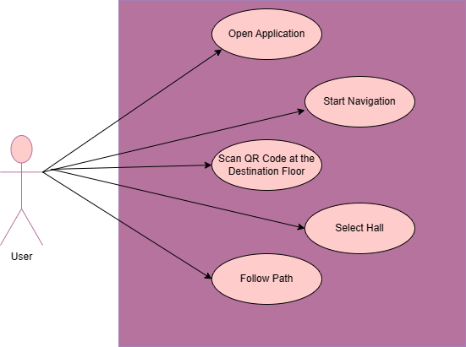

Figure 22 Engineering Faculty Compass Use Case Diagram

### **3.4.2** **Use Case Description**

1.Open Application:

Table 11 Use Case Open Application.

|  |  |
| --- | --- |
| Use Case | Open application |
| Actors | User |
| Type | Essential and Primary. |
| Description | The user open the Engineering Faculty Compass application on their android smartphone. |

2. Scan QR code:

Table 12 Use Case Scan QR Code.

|  |  |
| --- | --- |
| Use Case | Scan QR code |
| Actors | User |
| Type | Essential and Primary. |
| Description | QR Code Scanning Feature: Within the application, the user scan QR code to determine its location at this point. |

3. Select the hall:

Table 13 Use Case Select The Hall.

|  |  |
| --- | --- |
| Use Case | Select the hall |
| Actors | User |
| Type | Essential and Primary. |
| Description | There is a dropdown menu for each floor within the application, the user choose the desired hall in the desired floor within the Faculty of Engineering. |

.

4. Path generation (follow path):

Table 14 Use Case Follow Path.

|  |  |
| --- | --- |
| Use Case | Path generation (follow path) |
| Actors | User |
| Type | Essential and Primary. |
| Description | After the user selects their destination, the application display a visual line to guide the user from their current location to the chosen destination. |

### **3.4.3** **Sequence diagram**

An example of an interaction diagram is a sequence diagram, which shows how objects interact in a specific scenario or use case. As shown in figure 23, where we note that the user and the application are active throughout the period of use, and what is left is active for the period of carrying out its function and then it will be deactivated, it displays the sequence of messages exchanged between the objects, which are the user, the application, the QR code scanner, A* algorithm and line renderer component, side by side.

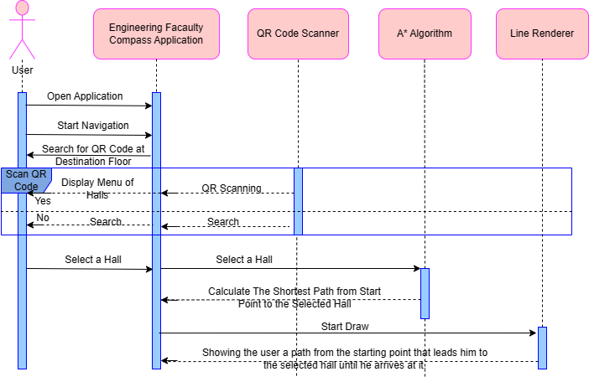

Figure 23 Sequence Diagram

### **3.4.4** **Activity diagram**

An activity diagram in UML is a specific type of behavioral diagram that displays the progression of activities for a procedure, process, or workflow. It is employed to model organizational processes, software workflows, and business processes. To demonstrate how various actions in our application interact with one another, see figure 24. Begin by opening the app, scanning the QR code in desired floor, selecting a hall from a list of halls, and then displaying a visual line to help get to the desired hall.

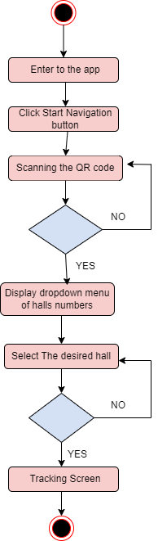

Figure 24 Activity Diagram

## **3.5 Simulation and/or Experimental Test**

In this section, we test our project in unity simulation to make sure that it gives us the results we want.

One of the advantages of Unity is that it allows developers to test and interact with UI elements in real time by clicking on the run button. This allows for immediate adjustments, rapid progress, and the ability to identify and fix errors quickly.

### **3.5.1 Welcome Screen**

Figure 25 show panorama view of our Engineering Faculty with Start Navigation button to start navigation.

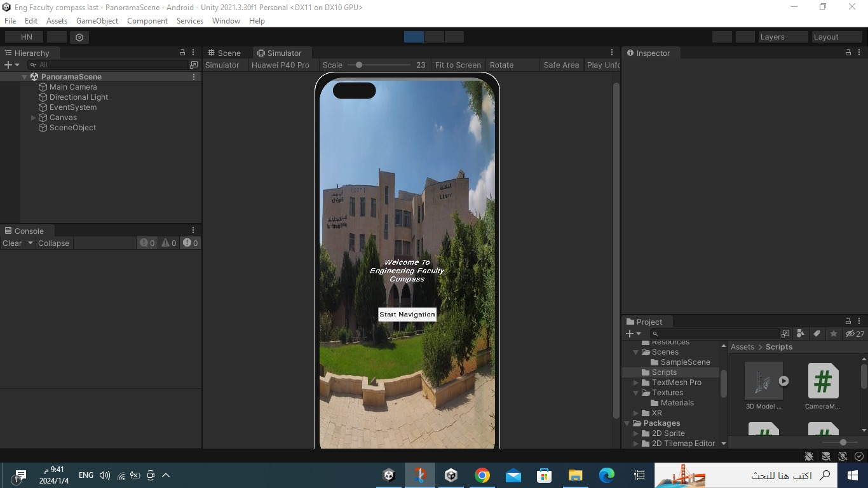

Figure 25 Welcome Screen

### **3.5.2 Scan QR Code Screen**

This screen allow user to open camera to scan the QR code of the desired floor.

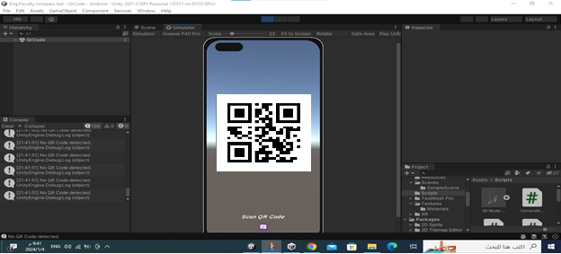

Figure 26 Scan QR Code Screen

### **3.5.3 Ground Floor Halls Menu Screen**

Figure 27 shows a menu that displays after scanning the QR code of the ground floor. This menu contains the numbers of all halls in the ground floor. We select EIT001 to test the path of this hall.

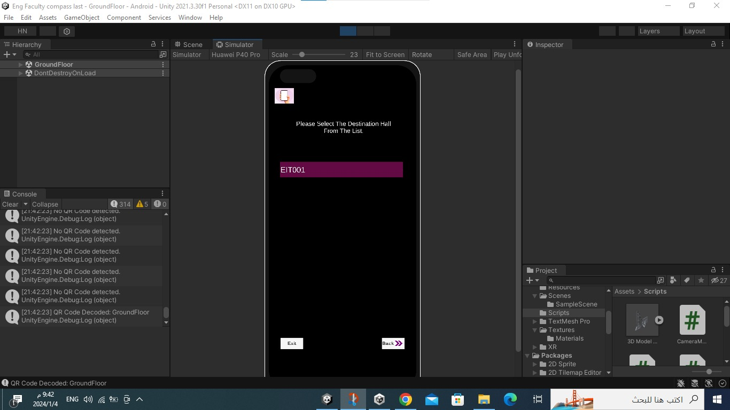

Figure 27 Ground Floor Halls Menu Screen

### **3.5.4 EIT001 hall path**

Figure 28 displays the line renderer component that drawn from start position to the EIT001 hall.

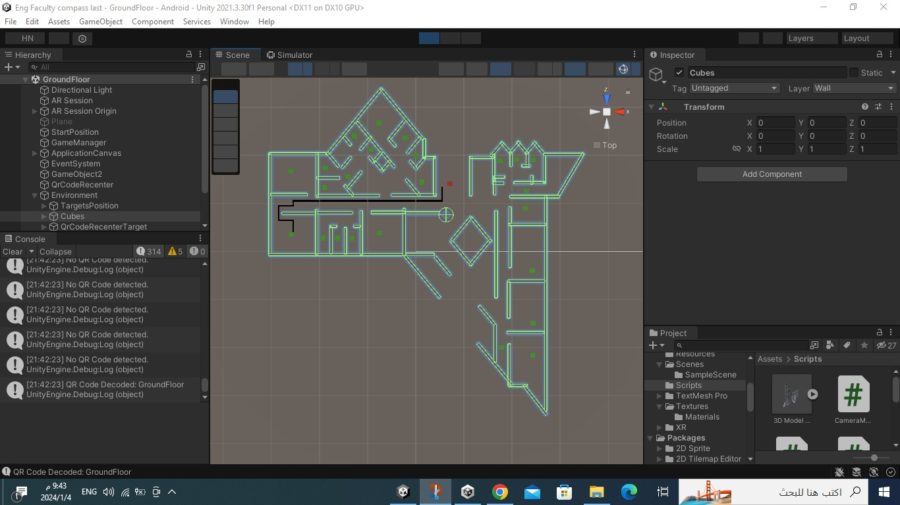

Figure 28 EIT001 hall path

### **3.5.5 First Floor Halls Menu Screen**

Figure 29 shows a menu that displays after scanning the QR code of the first floor. This menu contains the numbers of all halls in the first floor. We select EIT101 to test the path of this hall.

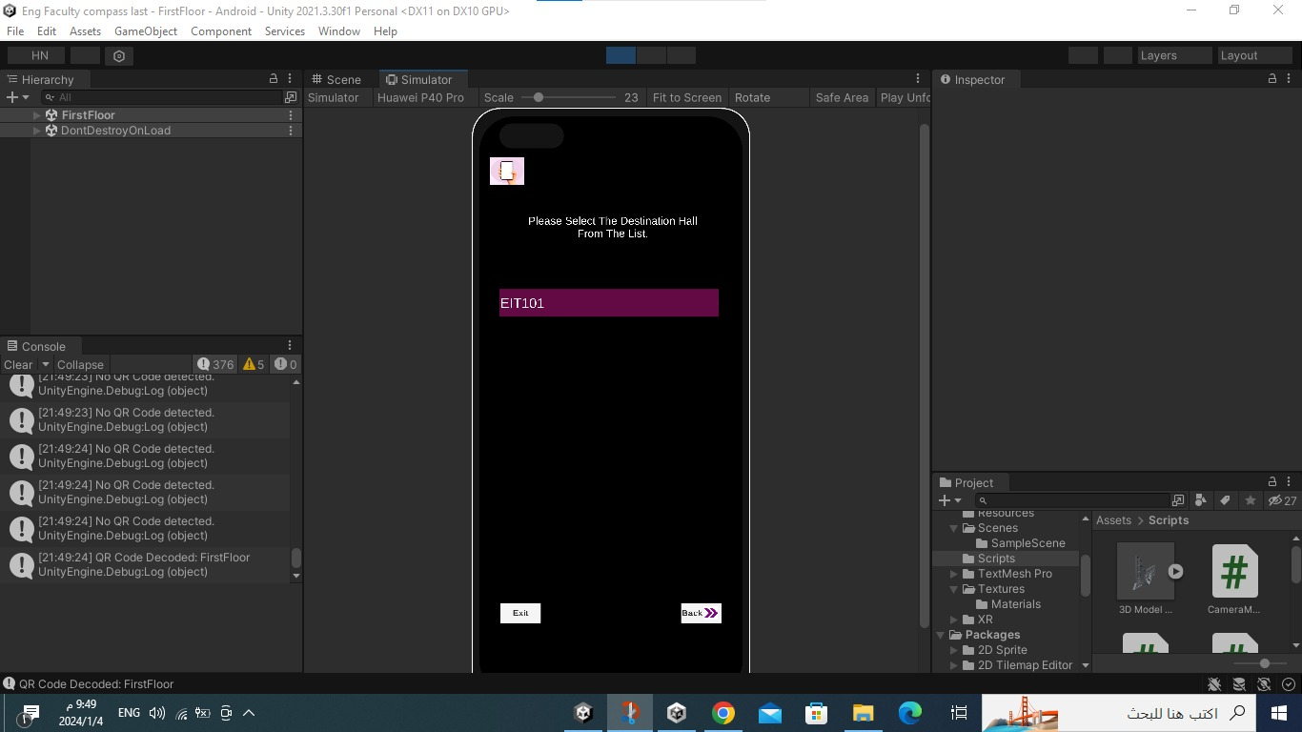

Figure 29 First Floor Halls Menu Screen

### **3.5.6 EIT101 hall path**

Figure 30 displays the line renderer component that drawn from start position to the EIT101 hall.

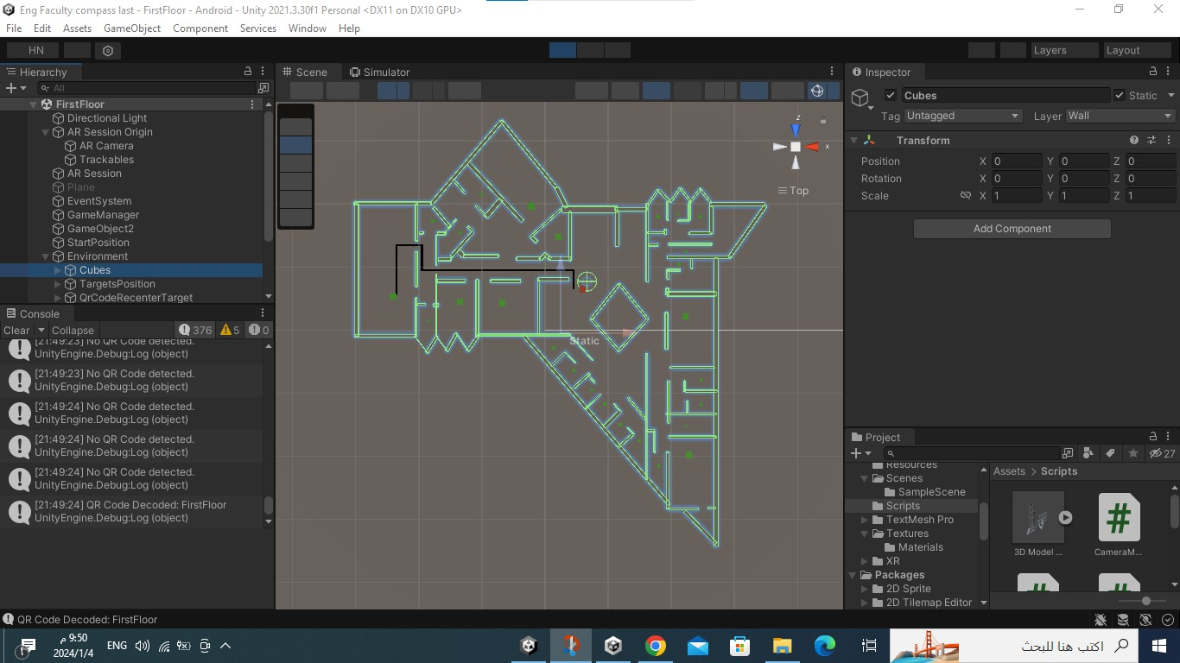

Figure 30 EIT101 hall path

### **3.5.7 Second Floor Halls Menu Screen**

Figure 31 shows a menu that displays after scanning the QR code of the second floor. This menu contains the numbers of all halls in the second floor. We select EIT201 to test the path of this hall.

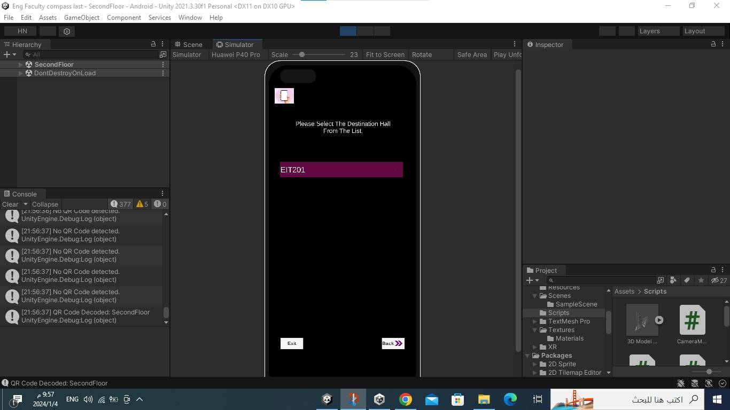

Figure 31 Second Floor Halls Menu Screen

### **3.5.8 EIT201 hall path**

Figure 32 displays the line renderer component that drawn from start position to the EIT201 hall.

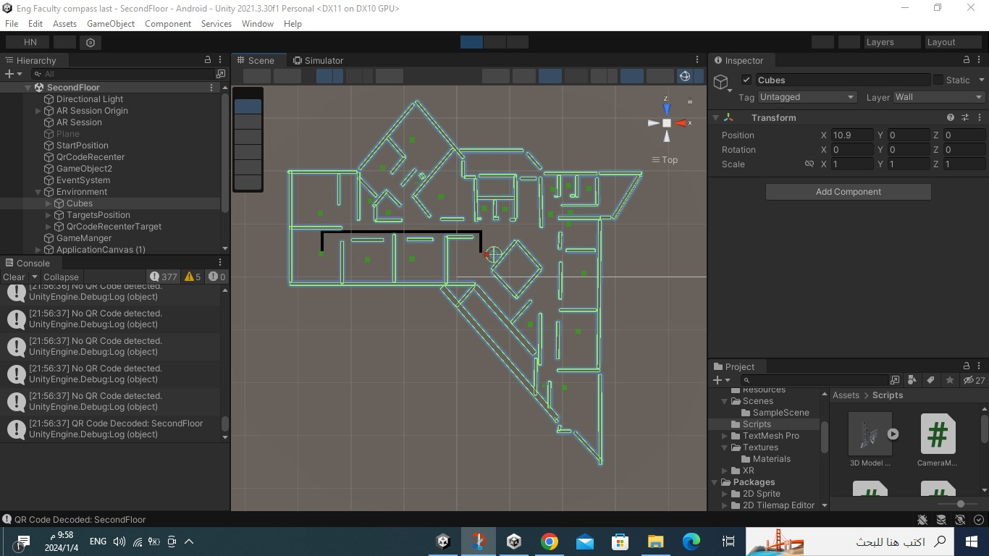

Figure 32 EIT201 hall path

**CHAPTER 4: Results and Discussions**

In this chapter will we talk about our final results and discussion about Unity and Screen Cloud features.

## **4.1 Results**

### **Engineering Faculty Compass Logo**

The Logo of our app is EFC refers to Engineering Faculty Compass that is displayed once the user opens the app.

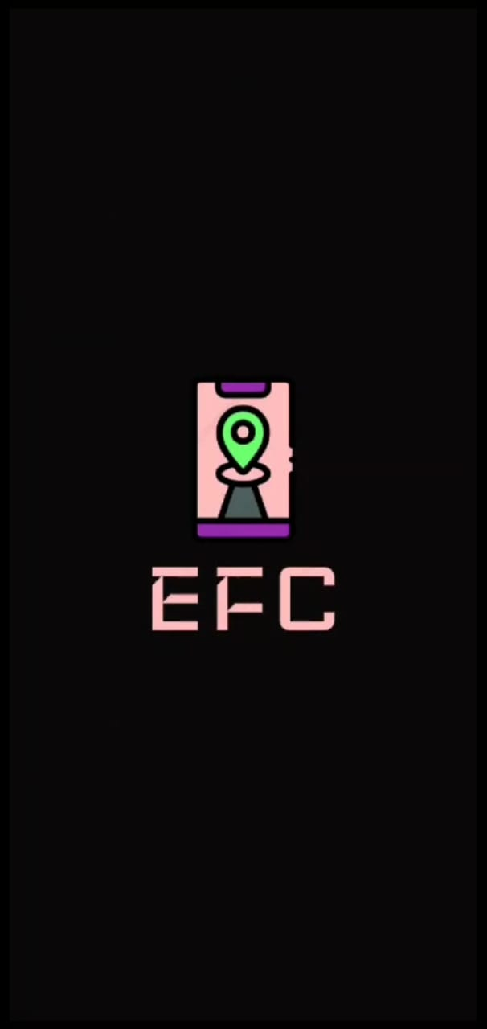

Figure 33 Application Logo

### **Welcome Screen**

The welcome screen contains an image of an Engineering Faculty and a Start Navigation button to start navigation.

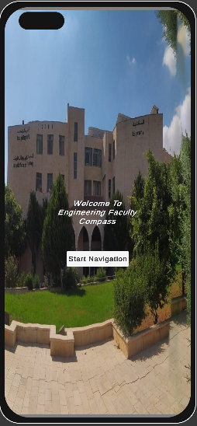

Figure 34 Welcome Screen

### **Scan QR Code Screen**

This page allows to open mobile camera to scan the QR code that exists in the desired floor.

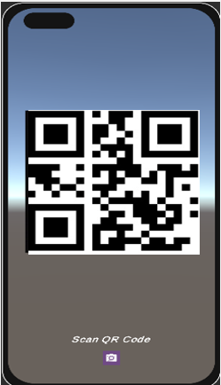

Figure 35 Scan QR Code Screen

### **Halls Menu Screen**

This screen contains a dropdown list of halls in desired floor that allow user to select a destination hall, Back button allow user to back to the scan QR Code screen and Exit button to exit from the app.

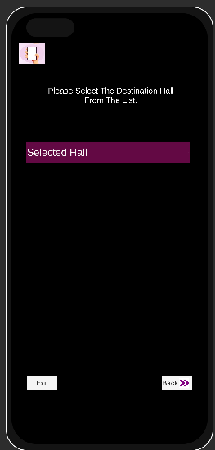

Figure 36 Halls Menu Screen

### **Tracking Screen**

This screen displays the virtual line renderer component that drawn on the mobile screen from start position to the selected hall in the real world inside Engineering Faculty that allow user to trace it until reach the selected hall. In figure 37 the selected hall is EIT002.

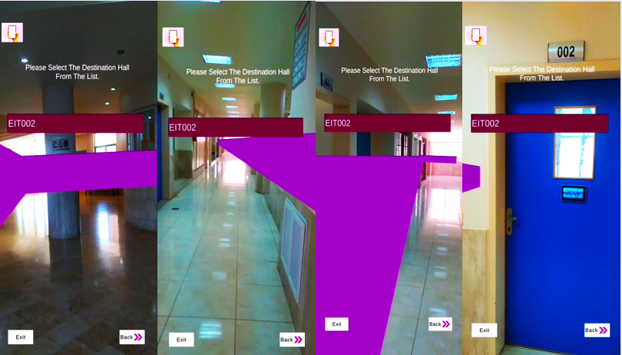

Figure 37 Tracking Screen

These are the links to videos of our app when the user is navigating in different halls on different floors.

1. [Floor 0 Video.mp4](https://1drv.ms/v/c/30e1d7d036860f79/EWE3F2HHdgFIhz68q1I6IIABlrtOQVFPlKcmWGXMiFTsDg?e=8k0LRH)
2. [Floor 1 Video.mp4](https://1drv.ms/v/c/30e1d7d036860f79/ERKDmgygIKtPttqGlfZb2SMBueZQFTPvWJil6K5FNdFzUg?e=sgSwO9)
3. [Floor 2 Video.mp4](https://1drv.ms/v/c/30e1d7d036860f79/ETGJM2U9vJtLskLO5e3y97gBz65B4yW73GppRJA4iP8QiQ?e=vtdETQ)

This is the link to the application in apk format:

[ENG Faculty Compass app.apk](https://1drv.ms/u/c/c8b1d2dbc530cc1e/EaMnwyE--lNGuBt-xXb8v_ABOIkheVdFhsvKzvtznd8S0w?e=BuTCfu)

This is the link to the QR code for each floor

[QR codes](https://aaujedu-my.sharepoint.com/:w:/g/personal/h_nueirat_student_aaup_edu/EUnak0V_7vpAsjRlpxLEuIkBb65NfF9Cl0vlmefKnRyNxA?e=Sq20Ld)

### **Screen Interfaces**

The screen that hung on the hall door displays the important information halls such as lecture name, lecturer name, number of students in it, its duration and the next lecture by using Cloud Screen to schedule the slides and design it, in the next figures show the EIT001 hall information in Sunday, Tuesday and Thursday.

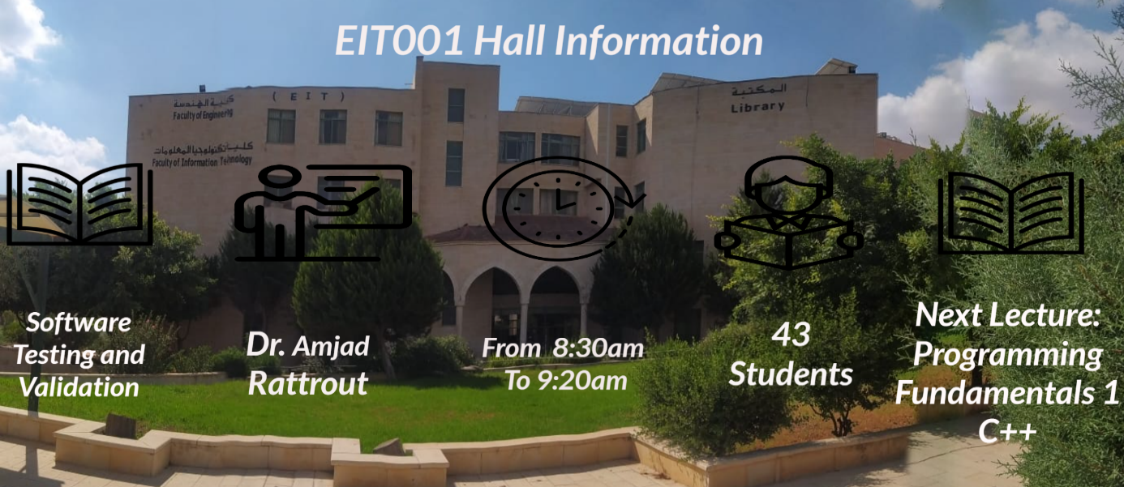

Figure 38 Hall Information screen1

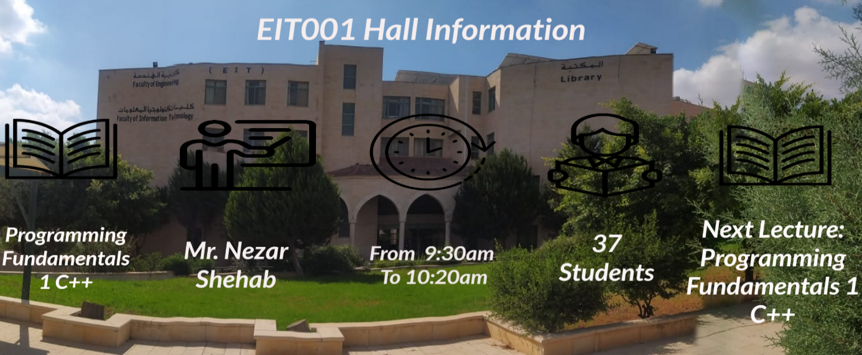

Figure 39 Hall Information Screen2

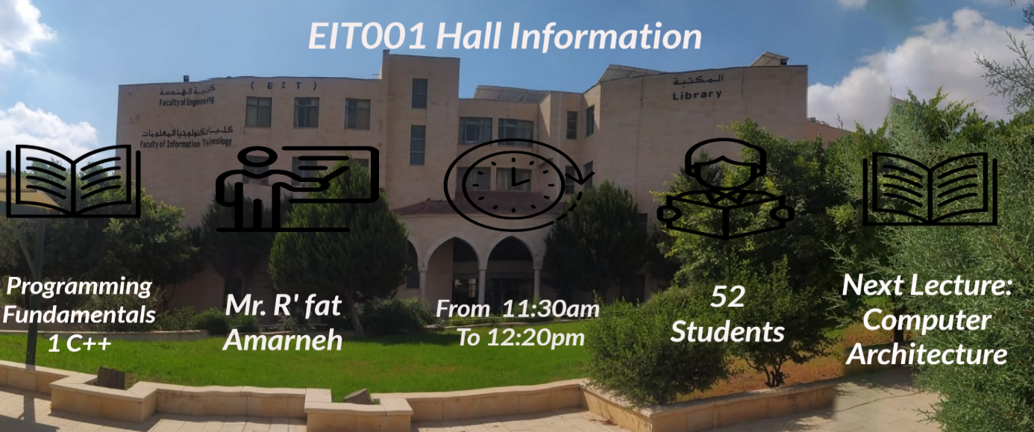

Figure 40 Hall Information Screen3

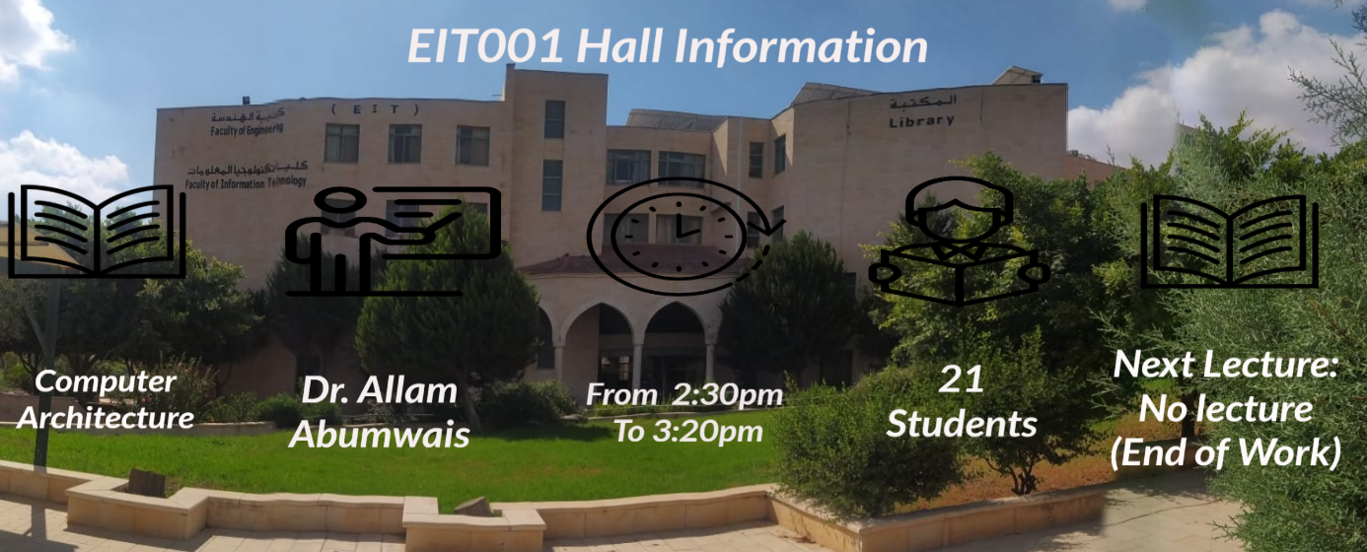

Figure 41 Hall Information Screen4

## **4.2 Discussions**

In this section will display some discussions about Unity and Screen Cloud.

### **4.2.1 Discussion about Unity:**

1. The Unity platform provides all the packages and libraries for Android and AR applications.

2. Unity has all the features needed for mobile development without the need for integration APIs to develop our app.

3. Engineering Faculty Compass User Interface (UI) self-explanatory and easy to use.

4. The app will be installed in Android mobile phones.

5. The app is not large (63.23 MB) and can be easily installed.

### **4.2.2 Discussion about Screen Cloud**

1. Using screen cloud is very easy.

2. Displaying information in arranged way and scheduled.

3. Screen Cloud is free.

**CHAPTER 5: Project Management**

In this chapter will be show how we divided the project works between project team, and resources and costs.

## **5.1 Tasks, Schedule and Milestones**

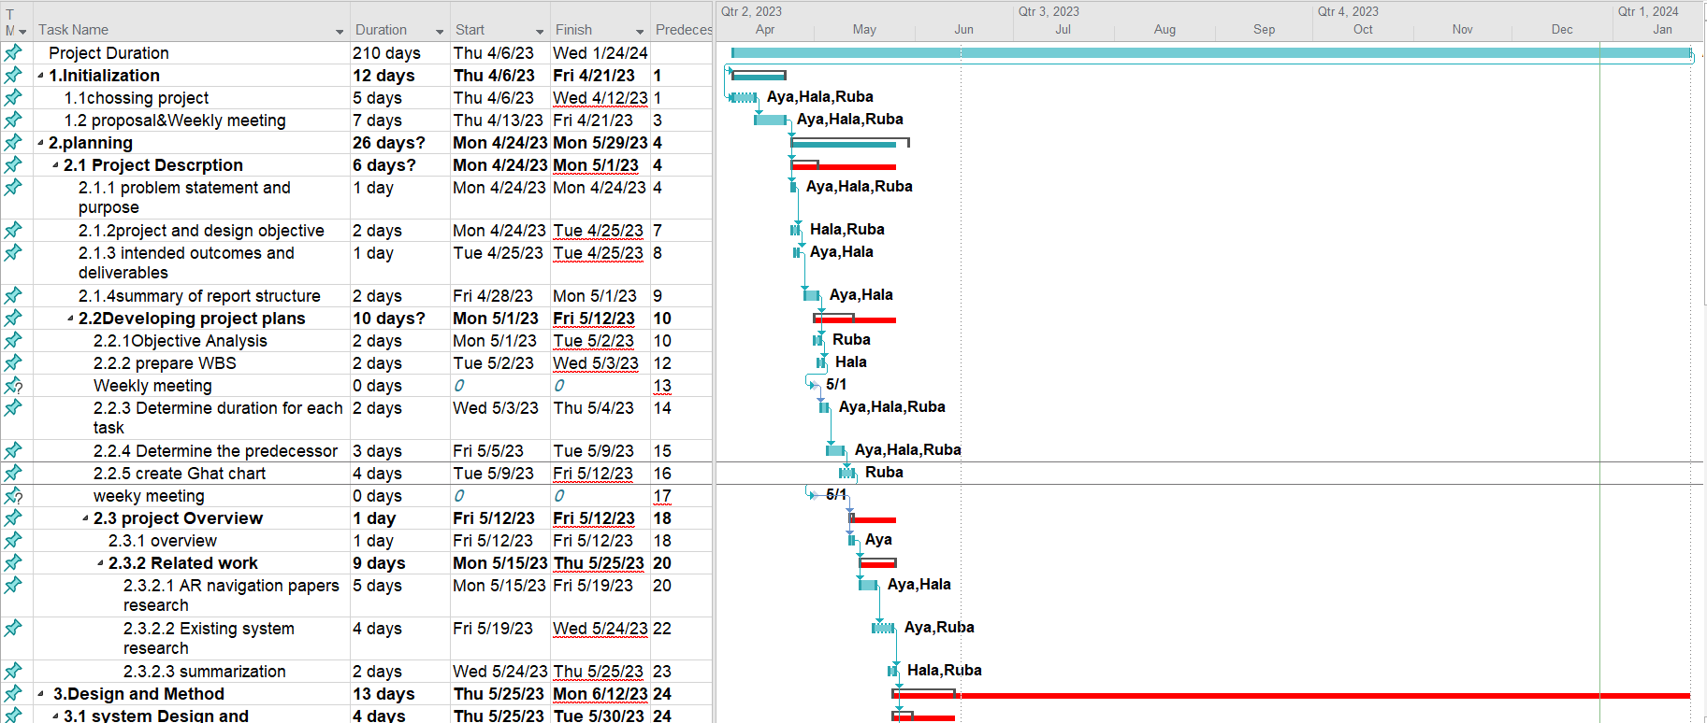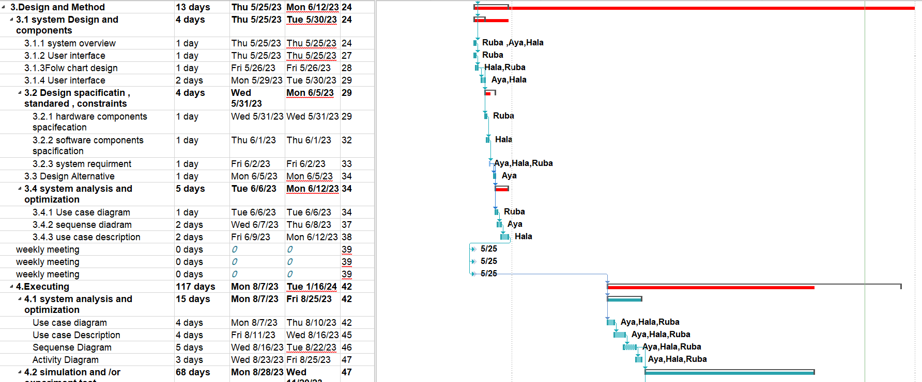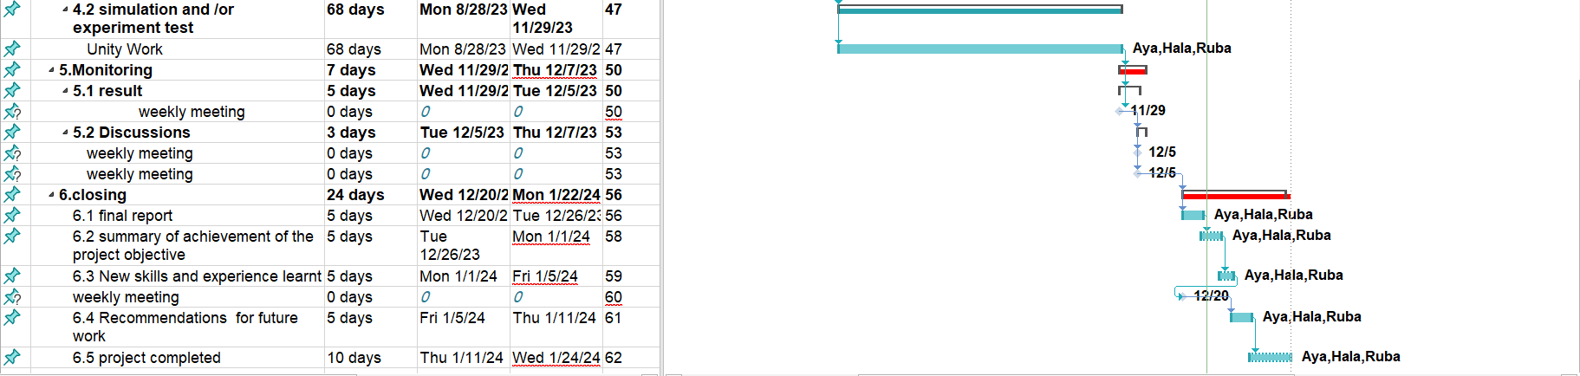

Figure 42 Gant Chart

## **5.2 Resources and Cost Management**

The cost of the project will depend on how hard the team members work since it is almost entirely a software project and we will be using software without a license.

Table 15 Sample Table To Fill In Total Cost Of Senior Project Items.

|  |  |  |  |  |
| --- | --- | --- | --- | --- |
| Item | # Unit | Unit Cost | Subtotals | Comments |
| Smart Screen | 1 | $200 | $200 |  |
| Unity | 1 | $0 | $0 |  |
| Total senior project estimate |  |  | $200 |  |

## **5.3 Lessons Learned**

1. The importance of setting goals and dividing them into manageable tasks.

2. Extensive research and gathering information about the project to understand it properly.

3. Teamwork its importance in completing the project in the required time.

4. It takes less time to complete each assignment when you have prior experience in the field you are working in. Since Unity is a new program for the team members, issues pertaining to selecting the right version of the software for the project as well as the requirement to pick up a new language unique to Unity have arisen.

5. Communication is a key factor in achieving high quality project and reduce problem among team member.

6. There is always a solution to a problem; it just takes time and restraint.

**CHAPTER 6: Impact Of The Engineering Solution**

This chapter contain the different impacts of our project and issues that faced us.

## **6.1 Economical, Societal and Global**

This section will describe our project's impacts on the environment, society, and economy.

### **6.1.1** **Economical Impact:**

By enhancing visitors' experiences at the faculty, this technology may have a favorable economic impact. By can assist in lowering the price of hiring a person to orient new students to the university.

### **6.1.2** **Societal Impact:**

Impact on the community: Our application makes it easier for visitors to move around and get where they need to go inside the faculty without stress or having to ask for assistance. Additionally, it aids in lessening faculty overcrowding, particularly when new students enroll.

## **6.2 Environmental and Ethical**

### **6.2.1 Environmental effects:**

Because our system doesn't use a lot of energy or resources to implement, its environmental effects are relatively small. The use of widely used smartphones is its main foundation.

## **6.3 Other Issues**

We tried to put all of the concepts from the first senior project into practice, and we were successful in doing so. In addition, we computed the shortest path from the starting point to the desired hall by applying the A* algorithm. First, we had to deal with the requirements for the laptop in order to download Unity and use it quickly and efficiently. This included improving the device's RAM and SSD. It took us a while to become skilled with it and to understand how it functioned. Second, we faced a problem with the 3D model. We built the 3D model in Autodesk Fusion 360 and imported it into Unity, but this model was not recognized as a wall for the purpose of collision because the model does not contain a collision component, and since the 3D model contains many details and shapes, it is difficult to add a collision component to it. We solved this problem by using 3D object cube already built in unity and contain collider component. So first we bring the plane of each floor then built the 3D model using the 3D objects cubes on the plane of each floor. Third, we encountered an issue where the AR camera was not tracking the line because we used the Line Renderer component in Unity without the LeanTween package. We solved this issue by installing the LeanTween package from Unity's package manager so it's easier to move the AR camera along a specified path. We also encountered issues with the Xibo program, so we turned to Cloud Screen.

**CHAPTER 7: Conclusions and Recommendations**

This chapter contains our final conclusions and our recommendations for anyone considering a similar project to ours.

## **7.1Summary of Achievements of the Project Objectives**

1. The project was effectively finished

2. The application was used to conduct experiments, which demonstrated its effectiveness in assisting the user in locating the path and achieving his objective.

3. The information about the halls was displayed on the smart screen for the user's awareness.

4. It's now quicker for new students to discover the hall than it was before.

## **7.2 New Skills and Experiences Learnt**

1. We gained knowledge on how to use Unity to create an AR application.
2. We learned how build 3D model in unity.
3. We have a 50% proficiency in C# for Unity.
4. We gained knowledge on how to utilize Screen Cloud and link it to the Screen Cloud Player app.
5. We gained general knowledge about using the Unity application.

## **7.3Recommendations for Future Work**

### **7.3.1** **Recommendations**

1. We hope that businesses will embrace our idea and work with us to further enhance it.

2. We want to see our idea developed so that a larger user base can benefit from it.

### **7.3.2** **Future Work**

1. University faculties are the target audience for this application, not merely the Faculty of Engineering.

2. Develop an app that works with both android and iOS devices.

3. Utilizing the smart screen technology throughout all university faculties.

4. Integrate the app with university system to obtain the data directly from the university.

# **References**

|  |  |
| --- | --- |
| [1] | [Online]. Available: https://sopa.tulane.edu/blog/whats-difference-between-ar-and-vr. [Accessed 9 June 2023]. |
| [2] | [Online]. Available: https://3dwayfinder.com/feature/. [Accessed 9 6 2023]. |
| [3] | [Online]. Available: https://apps.apple.com/us/app/genesis-virtual-guide/id1265717613. [Accessed 9 6 2023]. |
| [4] | [Online]. Available: https://play.google.com/store/apps/details?id=com.chuna0.ARYamaNaviU. [Accessed 9 6 2023]. |
| [5] | [Online]. Available: https://images.app.goo.gl/ZTdy4CJ85DPmzp8B8. [Accessed 9 6 2023]. |
| [6] | [Online]. Available: https://images.app.goo.gl/G8yZvRCgzJsYaVrc9. [Accessed 9 6 2023]. |
| [7] | [Online]. Available: https://www.qr-code-generator.com/. [Accessed 6 11 2023]. |
| [8] | [Online]. Available: https://www.qr-code-generator.com [Accessed 11 6 2023]. |
| [9] | [Online].Available:https://th.bing.com/th?id=OIF.%2bMopQoxbFuT7KH2bk7799w&rs=1&pid=ImgDetMain. [Accessed 12 6 2023]. |
| [10] | [Online]. Available: https://venturebeat.com/business/microsoft-launches-visual-studio-online-public-preview-and-ml-net-1-4. [Accessed 12 6 2023]. |
| [11] | [Online]. Available: https://screencloud.com/. [Accessed 24 12 2023]. |
| [12] | [Online].Available: https://th.bing.com/th/id/R.f16ed1c2f2a58d0bf1156b4d1038044b?rik=Z316yC5Az0Ds5g&riu. [Accessed 10 6 2023]. |
| [13] | [Online]. Available: https://yt3.ggpht.com/a-/AN66SAx2_nEr5N_b1cXFVb_LP2YNUtmCeQ8QapsgMg=s900-mo-c-c0xffffffff-rj-k-no. [Accessed 12 6 2023]. |
| [14] | Y. K. N. I. S. A. K. T. Wada, "Multimodal User Interface for QR Code based Indoor Navigation System," in *IEEE 9th Global Conference on Consumer Electronics (GCCE)*, 2020. |
| [15] | [Online].Available:https://docs.unity3d.com/2021.3/Documentation/Manual/UnityManual.html. [Accessed 5 1 2024]. |

**APPENDICES**

**Appendix A:**

1. Node Class

Each instance of this class represents a node in a grid and has several properties like x and z position in the grid, whether it is a wall or not, world position, and information’s related to the A* pathfinding algorithm such as g cost, h cost, and F cost.

using System.Collections;

using System.Collections.Generic;

using UnityEngine;

public class Node

{

public int iGridX; //Grid Coordinates of the node in the X axis

public int iGridZ; // Grid Coordinates of the node in the Z axis

public int iGridY; // Grid Coordinates of the node in the Y axis

public bool bIsWall; //To check if the node obstcale or walkable

public Vector3 vPosition; //The global position of the Node in X,Y,Z axis

public Node ParentNode; //The Node where the current Node comes from it

public int igCost; //The cost of movement from start Node to the current Node

public int ihCost; //The heuristic distance from current Node to the target Node

public int FCost { get { return igCost + ihCost; } } //( FCost= igcost+ ihcost ) to decide the shortest path

public Node(bool a_bIsWall, Vector3 a_vPos, int a_igridX, int a_igridZ) //Node Constructor that takes 4 parameters

{

bIsWall = a_bIsWall; //To tell the program if the Node Wall or not

vPosition = a_vPos; //The global Position of the Node

iGridX = a_igridX; //Grid Coordinates of the node in the X axis

iGridZ = a_igridZ; //Grid Coordinates of the node in the Z axis

}

}

1. Grid Class

This class include several functionalities such as create a grid, finding neighboring nodes, get the closest node to the given world position, and drawing the path using the line renderer component.

using System.Collections;

using System.Collections.Generic;

using UnityEngine;

using System.Linq;

public class Grid : MonoBehaviour //To attach the Grid class to a GameObject

{

public LineRenderer lineRenderer;//LineRenderer Component for the path visualization

public Transform StartPosition;//The start position of the Grid

public LayerMask WallMask;//The wall layer to identify obstacles or Walls

public Vector2 vGridWorldSize;//The size of the Grid in world space

public float fNodeRadius;//The Radius of the Node

public float fDistanceBetweenNodes;//The distance between Nodes in the Grid

Node[,] NodeArray;//2D array to store objects of the Node class

public List<Node> FinalPath;//List of Nodes in the final path

float fNodeDiameter;//The derived variable diameter of the Node

int iGridSizeX, iGridSizeZ;//The derived variables represent the # of Nodes in X,Z dimensions in the Grid

private void Start()//Start Method

{

fNodeDiameter = fNodeRadius * 2;

iGridSizeX = Mathf.RoundToInt(vGridWorldSize.x / fNodeDiameter);

iGridSizeZ = Mathf.RoundToInt(vGridWorldSize.y / fNodeDiameter);

CreateGrid();//CreateGrid Method Calling

}

void CreateGrid()//CreateGrid Method

{

NodeArray = new Node[iGridSizeX, iGridSizeZ];//Intialize Node Array based on the Grid Size

Vector3 bottomLeft = transform.position - (Vector3.right * vGridWorldSize.x + Vector3.forward * vGridWorldSize.y) / 2; //bottomLeft Corner of the Grid calculation

for (int x = 0; x < iGridSizeX; x++)//Loop to make sure this does not go outside the boundaries of the Grid in X dimension

{

for (int z = 0; z < iGridSizeZ; z++)//Loop to make sure this does not go outside the boundaries of the Grid in Z dimension

{

float xpos = x * fNodeDiameter + fNodeRadius;//Calculate the x postion of the Node in the Grid, represent the x offset from bottomLeft of the Grid

float zpos = z * fNodeDiameter + fNodeRadius;//Calculate the z postion of the Node in the Grid, represent the z offset from bottomLeft of the Grid

Vector3 worldPoint = bottomLeft + new Vector3(Vector3.right.x * xpos, 0, Vector3.forward.z * zpos);//world position of the node in the grid

bool Wall = !Physics.CheckSphere(worldPoint, fNodeRadius, WallMask);//To check if the Node is wall or not

NodeArray[x, z] = new Node(Wall, worldPoint, x, z);//Create a Node Object assigned to the corresponding position in the Node Array

}

}

}

public List<Node> GetNeighboringNodes(Node a_NeighborNode)//Getting neighbor Node to the given Node

{

List<Node> NeighborList = new List<Node>();//Create empty list of Neighbor Nodes

int icheckX;

int icheckZ;

//checking the Right Side of the current Node

icheckX = a_NeighborNode.iGridX + 1;

icheckZ = a_NeighborNode.iGridZ;

if (icheckX >= 0 && icheckX < iGridSizeX)

{

if (icheckZ >= 0 && icheckZ < iGridSizeZ)

{

NeighborList.Add(NodeArray[icheckX, icheckZ]);

}

}

//Checking the left side of the current Node

icheckX = a_NeighborNode.iGridX - 1;

icheckZ = a_NeighborNode.iGridZ;

if (icheckX >= 0 && icheckX < iGridSizeX)

{

if (icheckZ >= 0 && icheckZ < iGridSizeZ)

{

NeighborList.Add(NodeArray[icheckX, icheckZ]);

}

}

//Checking the Top side of the current Node

icheckX = a_NeighborNode.iGridX;

icheckZ = a_NeighborNode.iGridZ + 1;

if (icheckX >= 0 && icheckX < iGridSizeX)

{

if (icheckZ >= 0 && icheckZ < iGridSizeZ)

{

NeighborList.Add(NodeArray[icheckX, icheckZ]);

}

}

//Check the Bottom side of the current node.

icheckX = a_NeighborNode.iGridX;

icheckZ = a_NeighborNode.iGridZ - 1;

if (icheckX >= 0 && icheckX < iGridSizeX)

{

if (icheckZ >= 0 && icheckZ < iGridSizeZ)

{

NeighborList.Add(NodeArray[icheckX, icheckZ]);

}

}

return NeighborList;//The method Return a list of Neighbor Nodes

}

//Getting Closest Node to the worldpoint

public Node NodeFromWorldPoint(Vector3 a_vWorldPos)

{

float ixPos = ((a_vWorldPos.x + vGridWorldSize.x / 2) / vGridWorldSize.x);//Normlize the X position to the range[0,1]

float izPos = ((a_vWorldPos.z + vGridWorldSize.y / 2) / vGridWorldSize.y);//Normlize the Z position to the range[0,1]

ixPos = Mathf.Clamp01(ixPos);//To ensure that normlized position is within valid range[0,1]

izPos = Mathf.Clamp01(izPos);//To ensure that normlized position is within valid range[0,1]

int ix = Mathf.RoundToInt((iGridSizeX - 1) * ixPos);//Convert the normlized position to Grid coordinates

int iz = Mathf.RoundToInt((iGridSizeZ - 1) * izPos);//Convert the normlized position to Grid coordinates

return NodeArray[ix, iz];//Return the closest Node to the given worldpoint

}

public void DrawPath()//DrawPath Method to visualizing path by using LineRenderer Component

{

lineRenderer.positionCount = FinalPath.Count;//Set the number of positions in LineRenderer based on the number of positions in the FinalPath

lineRenderer.SetPositions(FinalPath.Select(a =>

{

Vector3 NodePosition = a.vPosition;

NodePosition.y -= 0.10f;//Adjust the Y position of each Node by subtracing 0.10f

return new Vector3(NodePosition.x, 0.0f, NodePosition.z);//Return the modified Positions of the LineRenderer to visualize the path in the scene

}).ToArray());

}

}

1. Pathfinding Class

This class contains many functions, including handle the dropdown value event, move the AR camera along the path, find the shortest path between start position and target position, generate the final path by retracing the steps from end node to start node.

using System;

using System.Collections;

using System.Collections.Generic;

using System.Linq;

using TMPro;

using UnityEngine;

using UnityEngine.UI;

public class Pathfinding : MonoBehaviour //To attach the Pathfinding class to a GameObject

{

private LTDescr CameraMovementTween;//Utilize LeanTween to move the AR Camera along the calculated path

public Action onTargetSelected; //Perform action when target selected

Grid GridReference;//for refernce the Grid class

public Transform StartPosition;//Start position to start path

public Transform TargetPosition;//Target Position to path finding

Vector3 currentTargetPosition; // The position of the current target

public Transform arCamera; // for reference to the AR camera

public TMP_Dropdown dropdown; //for reference to a TMP_Dropdown UI element

public Transform CubesParent; // for reference to the parent transform containing cube objects

// This method will be called whenever the TMP_Dropdown's value changes.

private void Awake()

{

GridReference = GetComponent<Grid>(); // get a reference to the Grid component attach to the GameObject

currentTargetPosition = TargetPosition.position; // Initialize the current target position

// Find the target GameObject by name and set the TargetPosition to its Transform

GameObject targetObject = GameObject.Find("GameObject2");

if (targetObject != null)//If GameObject2 is found

{

TargetPosition = targetObject.transform;//Set TargetPosition to the transform of that object

}

else

{

Debug.LogError("GameObject2 not found.");//If GameObject is not found (Error Handler)

}

onTargetSelected += () =>//onTarget Callback

{

FindPath(StartPosition.position, TargetPosition.position);//Find a path to the goal

if (GridReference.FinalPath != null && GridReference.FinalPath.Count > 0)

{

if (CameraMovementTween != null)

{

LeanTween.cancel(CameraMovementTween.id);//Cancel ARCamera movement

}

CameraMovementTween = arCamera.gameObject.LeanMoveSpline(GridReference.FinalPath.Select(a => a.vPosition).ToArray(), 40f).setOnComplete(() =>

{

CameraMovementTween = null;

});//Start a new ARCamera movemant along the calculated path

}

GridReference.DrawPath();//Call DrawPath method to visualize path on the Grid

};

}

public void OnDropdownValueChanged()

{

// Get the selected option from the dropdown

int selectedOption = dropdown.value;

string SelectedOptionText = dropdown.options[selectedOption].text;

Transform SelectedCube = CubesParent.Find(SelectedOptionText);

TargetPosition.position = SelectedCube.position;

// Perform actions based on the selected option

onTargetSelected?.Invoke();

}

private void MoveAlongPath()

{

// Check if the AR camera is found

if (arCamera == null)

{

Debug.LogError("AR Camera not found");

return;

}

// Check if there are nodes in the FinalPath

if (GridReference.FinalPath.Count > 0)

{

// Get the destination node (last node in the path)

Node destinationNode = GridReference.FinalPath[GridReference.FinalPath.Count - 1];

float step = 0.5f * Time.deltaTime; //The distance the AR camera should move

arCamera.position = Vector3.MoveTowards(arCamera.position, destinationNode.vPosition, step); // Move the AR camera towards the destination node by a distance of step

// Check if the AR camera has reached the destination node

if (Vector3.Distance(arCamera.position, destinationNode.vPosition) < 0.01f)

{

// Remove the reached node from the path

GridReference.FinalPath.RemoveAt(GridReference.FinalPath.Count - 1);

}

}

}

void FindPath(Vector3 StartPos, Vector3 TargetPos)//Method is responsible for A* pathfinding between the start and target positions

{

Node StartNode = GridReference.NodeFromWorldPoint(StartPos);//Getting the Node closest to the start postion

Node TargetNode = GridReference.NodeFromWorldPoint(TargetPos);//Getting the Node closest to the target postion

List<Node> OpenList = new List<Node>();// OpenList represents the list of nodes to be evaluated

HashSet<Node> CloseList = new HashSet<Node>();// CloseList represents the set of nodes that have already visited

OpenList.Add(StartNode);//Adding StartNode to the Openlist to initiate the A* algorithm

while (OpenList.Count > 0)//While there is Nodes in the open list

{

Node CurrentNode = OpenList[0];//creating Node and setting it the first item to the openlist

for (int i = 1; i < OpenList.Count; i++)//Loop through the open list starting from the second object

{

CurrentNode = (OpenList[i].FCost < CurrentNode.FCost || (OpenList[i].FCost == CurrentNode.FCost && OpenList[i].ihCost < CurrentNode.ihCost)) ? OpenList[i] : CurrentNode; //If the condition is True then Current Node=OpenList[i] else remains as it

}

OpenList.Remove(CurrentNode);//Remove the current Node from the open list

CloseList.Add(CurrentNode);//And add it to the close list to mark it as visited

if (CurrentNode == TargetNode)//If the current node is the same as the target node

{

GetFinalPath(StartNode, TargetNode);//Calculate the final path

}

foreach (Node NeighborNode in GridReference.GetNeighboringNodes(CurrentNode))//Loop through each neighbor of the current node

{

{

if (!NeighborNode.bIsWall || CloseList.Contains(NeighborNode))//Check If the neighbor is a wall or has already been checked

continue;//If the condition true skip the current neighbor

}

int MoveCost = CurrentNode.igCost + GetManhattenDistance(CurrentNode, NeighborNode); //Get the new g cost of that neighbor

if (MoveCost < NeighborNode.igCost || !OpenList.Contains(NeighborNode))//If new g cost of the neighbor node lower than existing g cost or neighbor node not exist in the open List

{

NeighborNode.igCost = MoveCost;//Set the current g cost to the new g cost

NeighborNode.ihCost = GetManhattenDistance(NeighborNode, TargetNode);//Set the h cost

NeighborNode.ParentNode = CurrentNode;//Set the parent of the node for retracing steps

if (!OpenList.Contains(NeighborNode))// if the neighbor Node not in the openlist

{

OpenList.Add(NeighborNode);//Add it to the list

}

}

}

}

}

void GetFinalPath(Node StartNode, Node EndNode)

{

List<Node> finalpath = new List<Node>();// list to hold the path sequentially

Node CurrentNode = EndNode;//Node to store the current node being checked

while (CurrentNode != StartNode)//Continue until the current node is the starting node

{

finalpath.Add(CurrentNode);//Add that Node to the final path

CurrentNode = CurrentNode.ParentNode;//Move onto its parent node

}

finalpath.Reverse();//Reverse the final path to get the correct order

GridReference.FinalPath = finalpath;//Set the final path

}

int GetManhattenDistance(Node a_nodeA, Node a_nodeB)//Is equal the sum of absloute differences in the X and Y coordinates between two Nodes

{

int ix = Mathf.Abs(a_nodeA.iGridX - a_nodeB.iGridX);//x1-x2

int iy = Mathf.Abs(a_nodeA.iGridY - a_nodeB.iGridY);//y1-y2

return ix + iy;// Return the sum

}

}

**Appendix B:**

**Appendix C:**